Task on Jenkins
- Install Jenkins and run Jenkins on port number 8081.
Create a ec2 instance ﻿named Jenkins
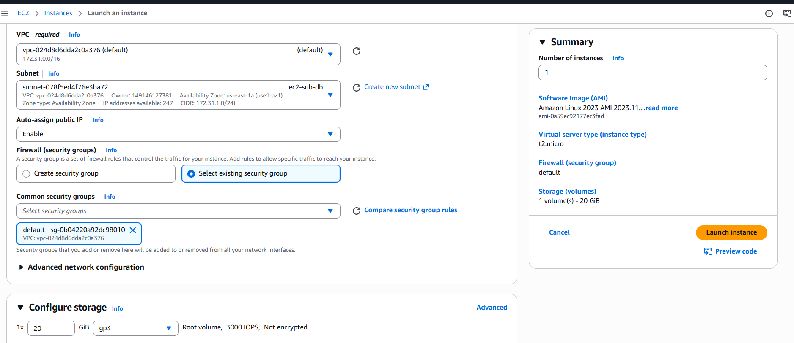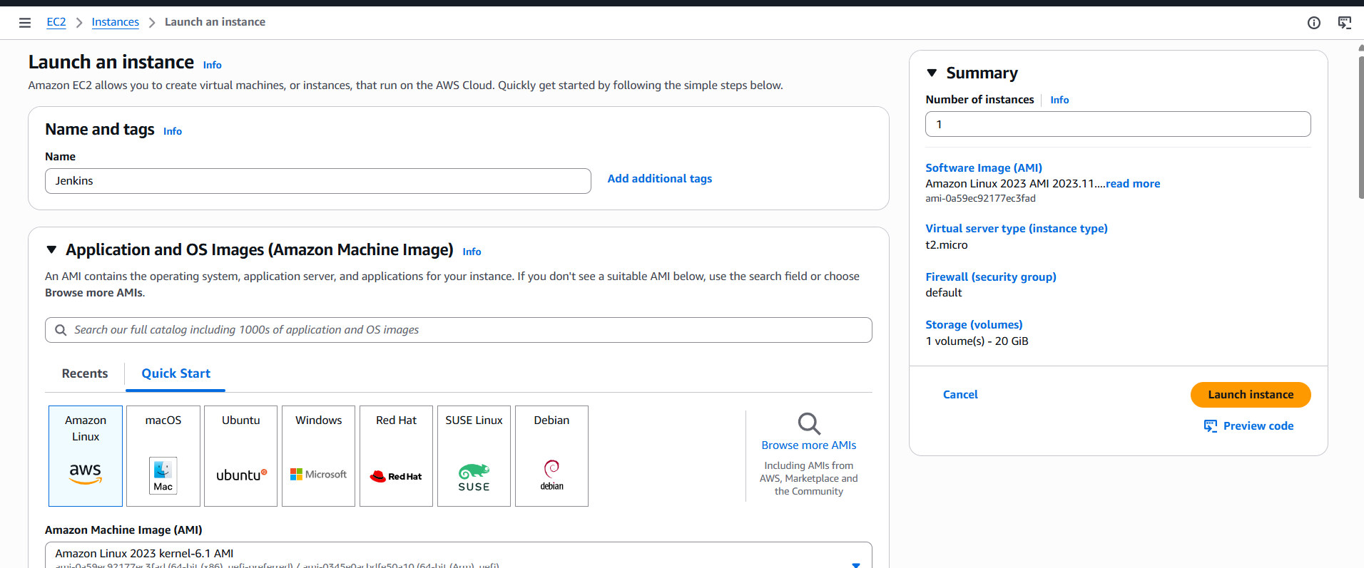
Gave 20 gb in configuration storage
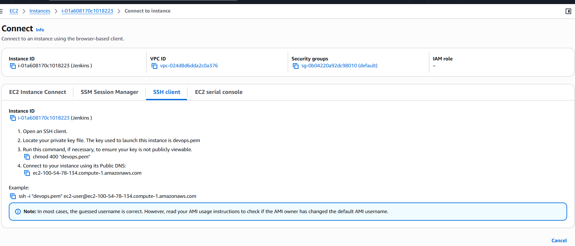
Connect to instance
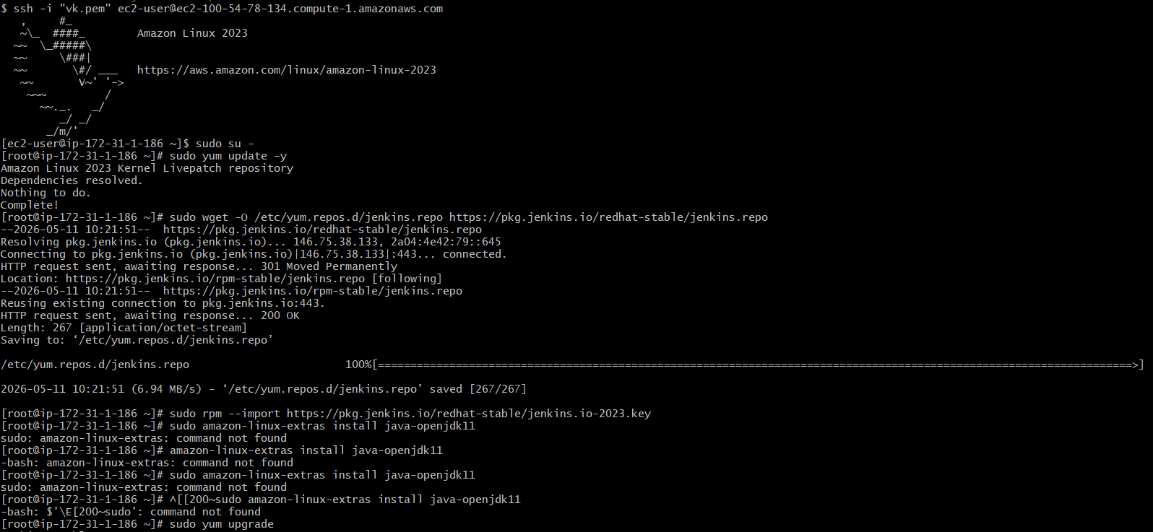
--Updated EC2 instance packages using sudo yum update -y.
--Added Jenkins repository to the system.
--Imported Jenkins repository key for package verification.
--Upgraded system packages using sudo yum upgrade.
--Installed Java 21 Amazon Corretto.
--Installed Jenkins successfully.
--Enabled Jenkins service at boot time.
--Started Jenkins service using systemctl.

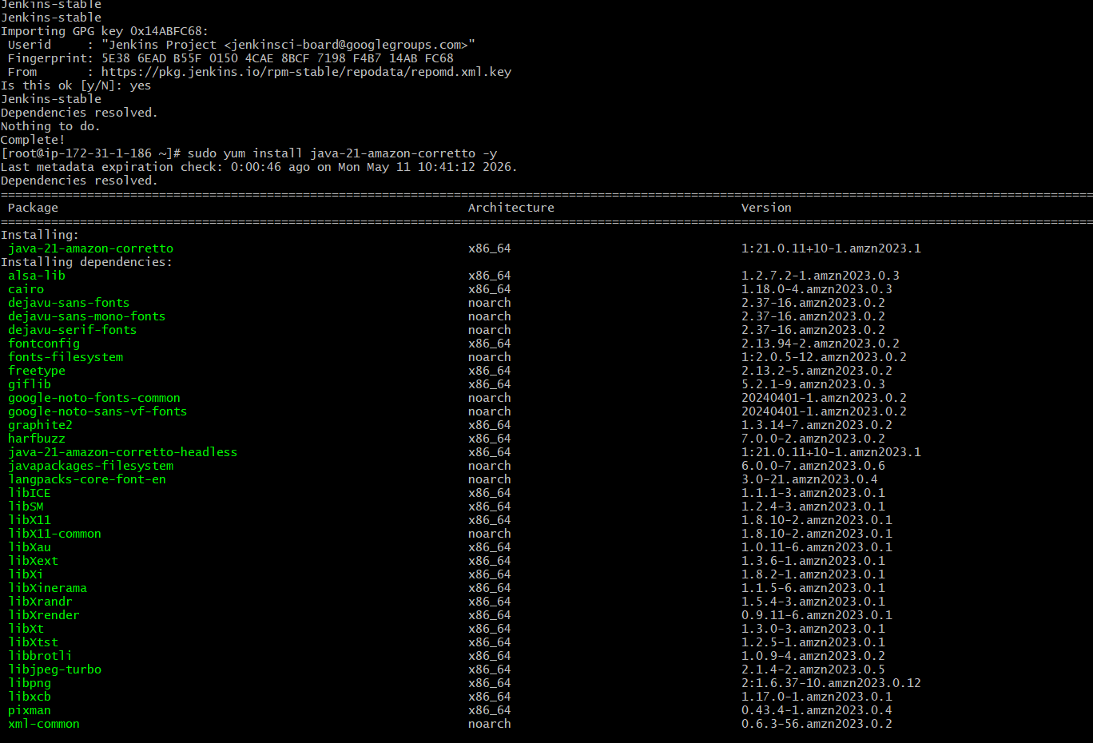
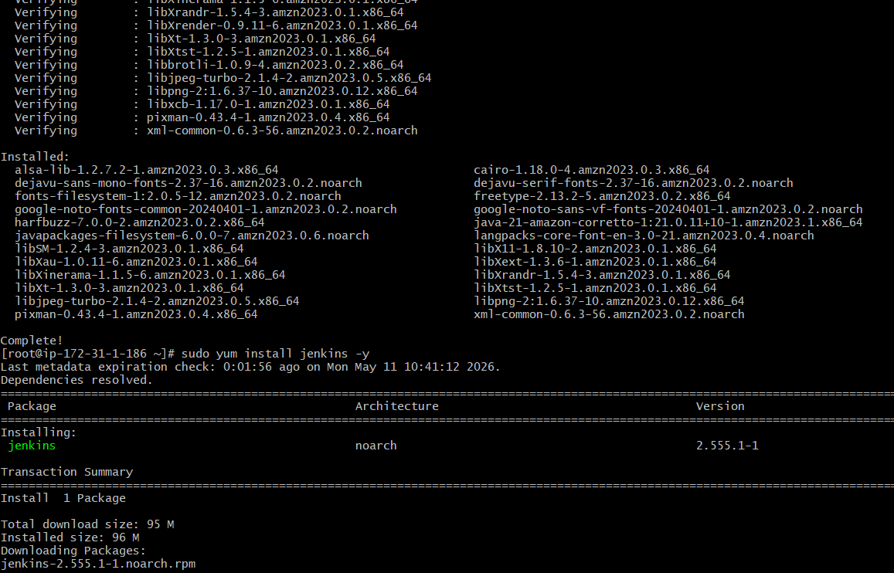

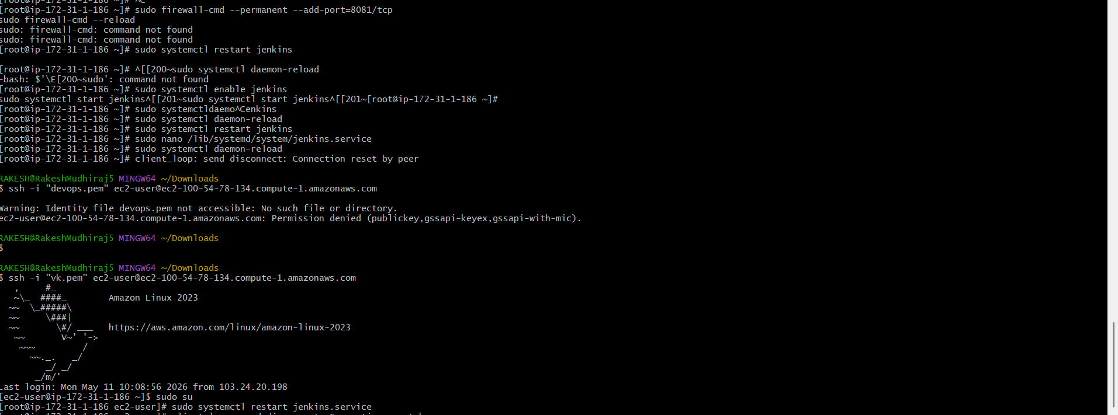
Jenkins is now installed and running on your EC2 instance. To configure Jenkins

Verified the browser

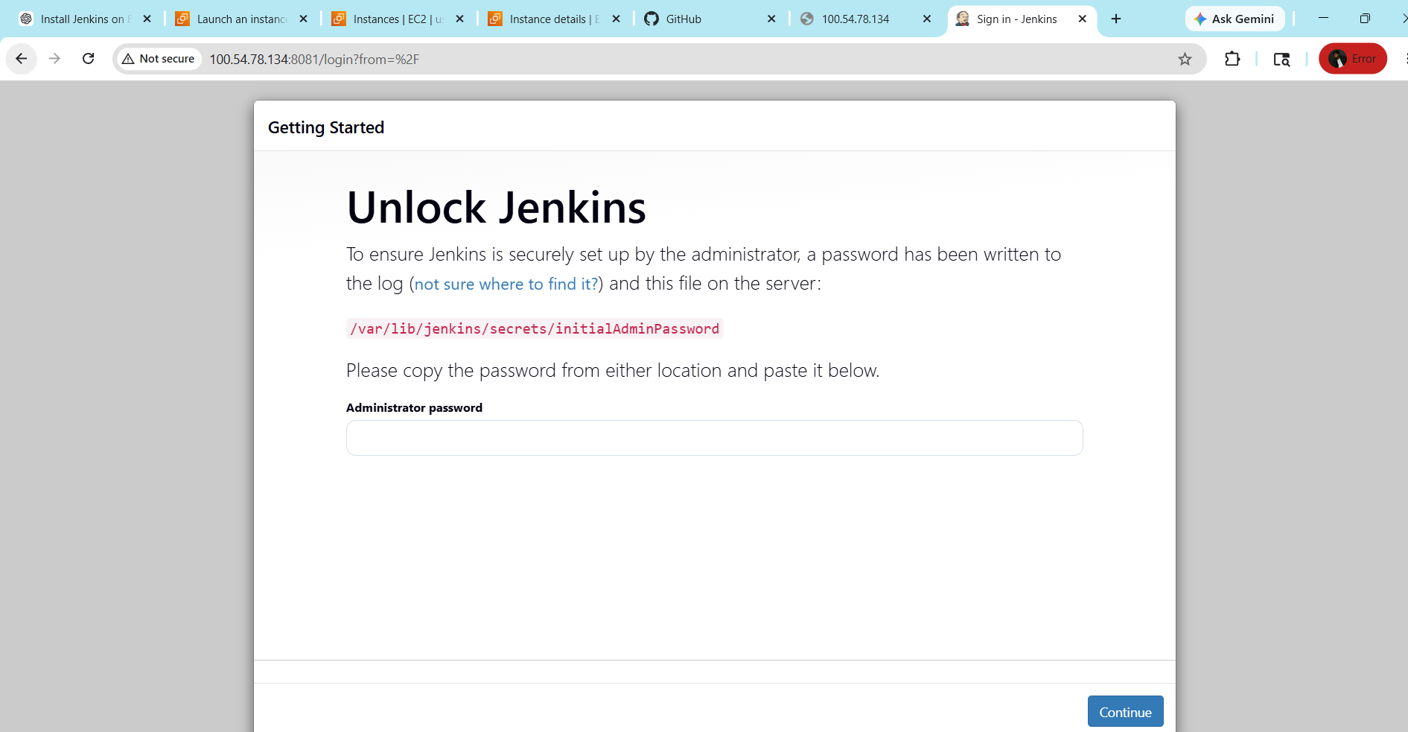

- Secure Jenkins server
Click on install suggested plugins
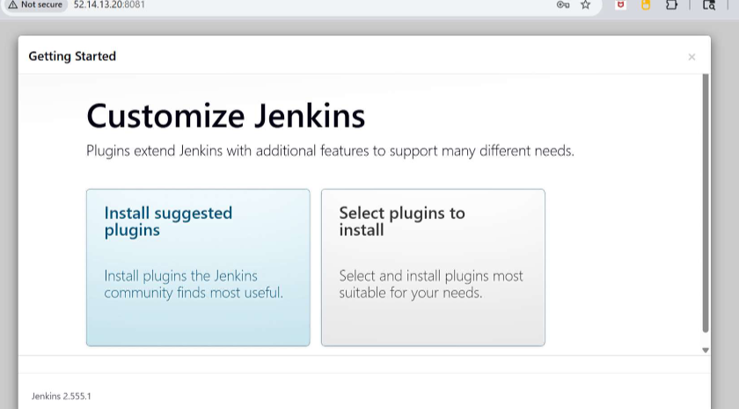

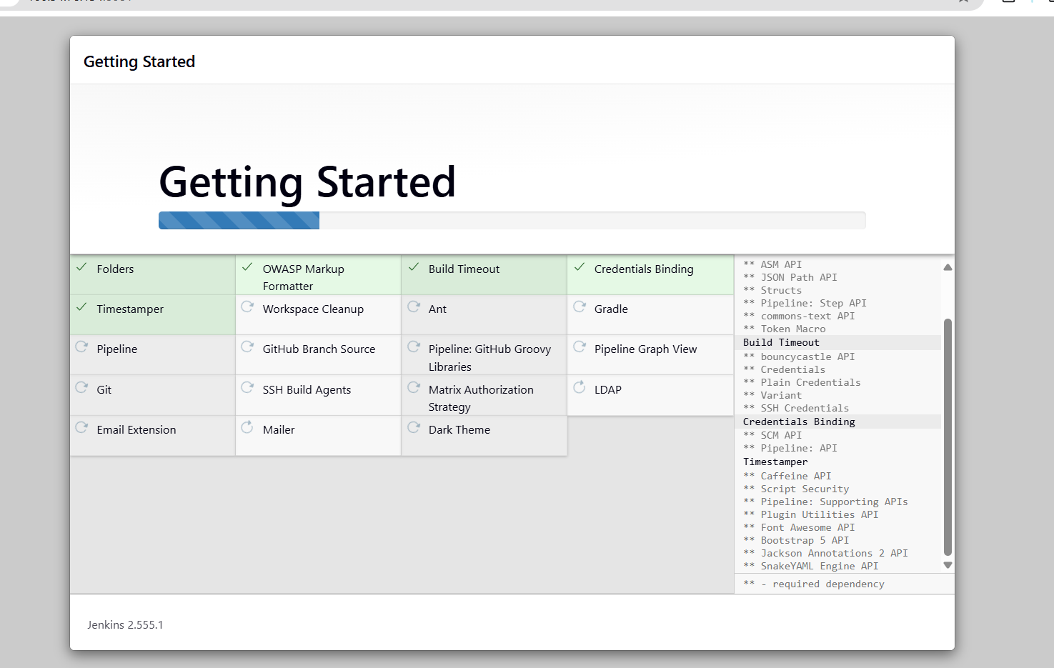
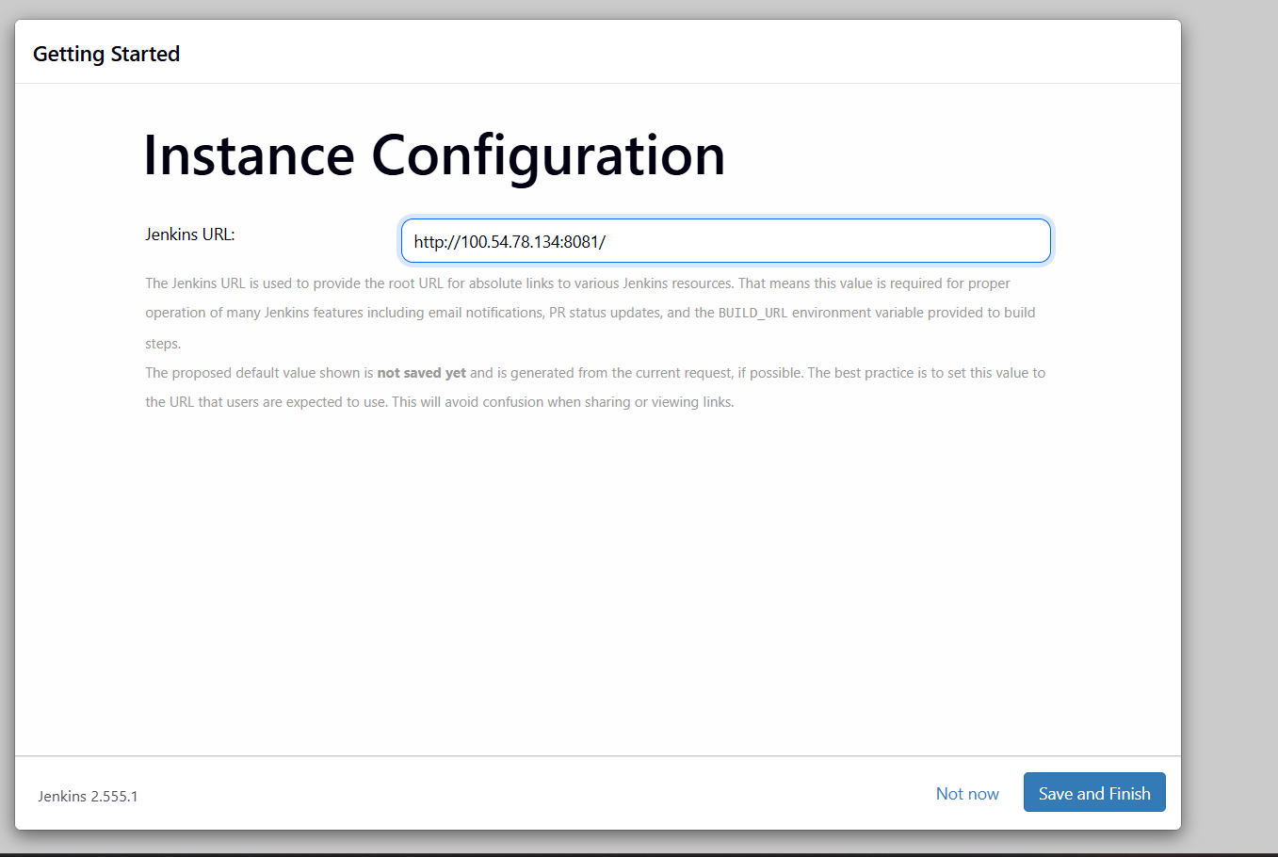
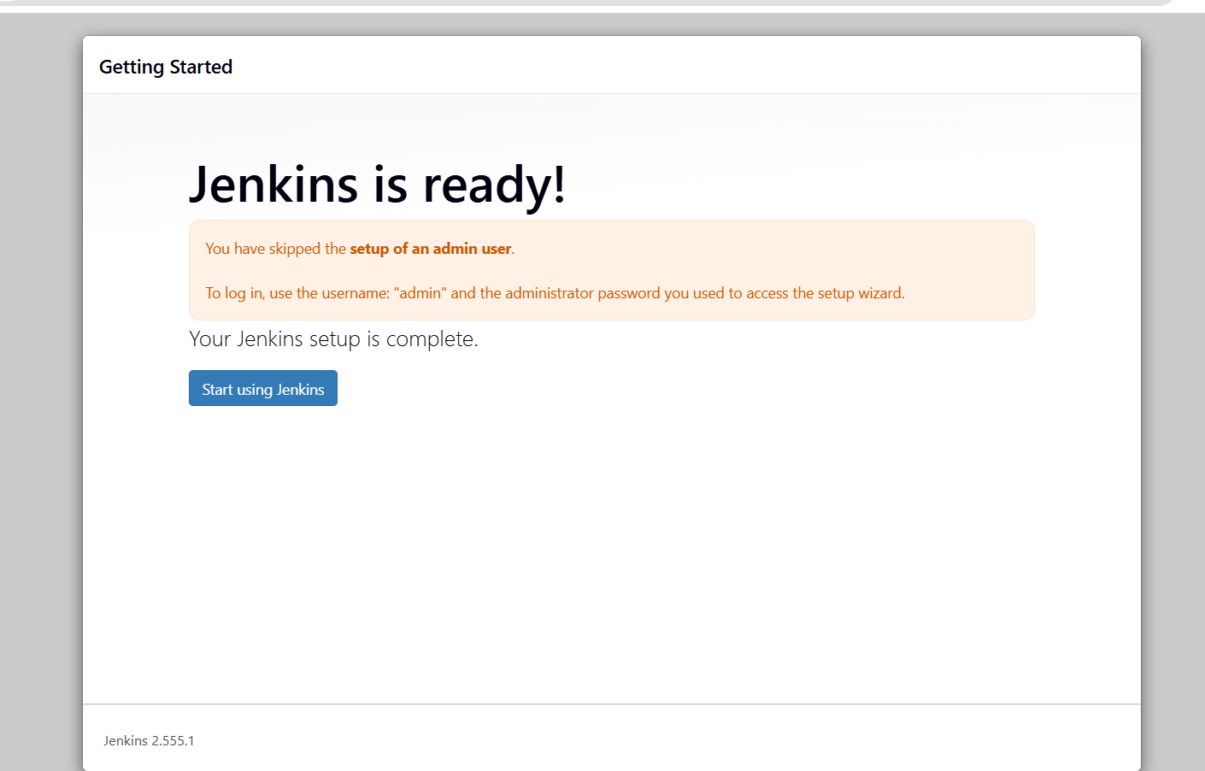
Now we can change the password
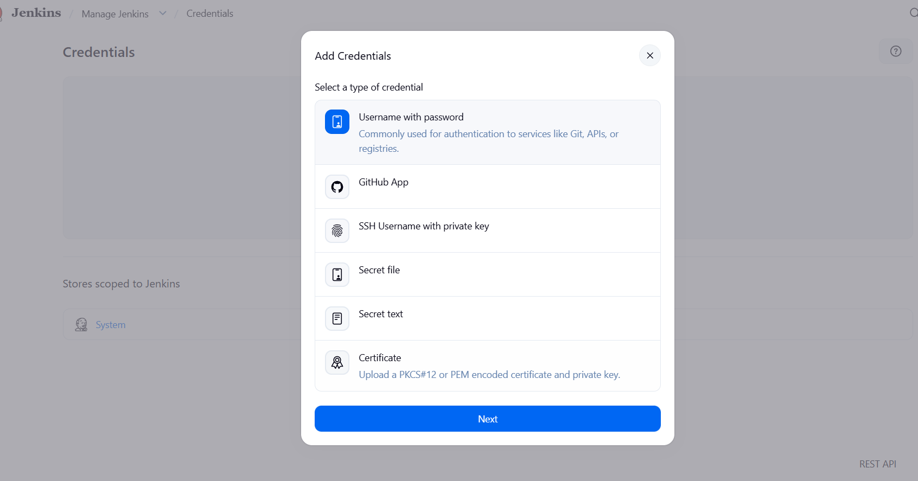
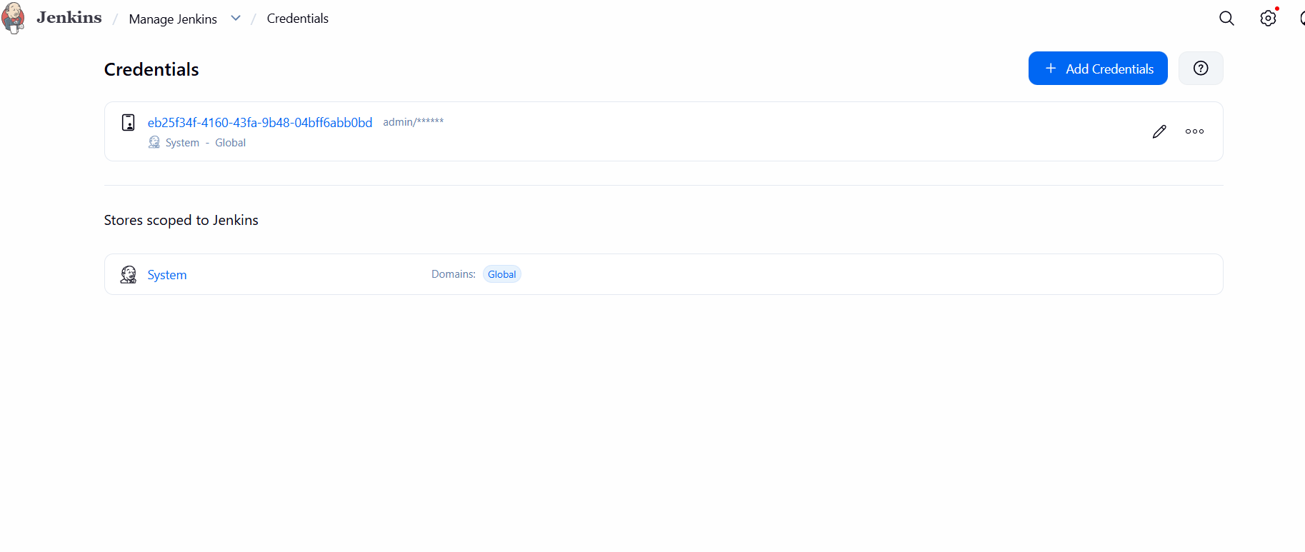
Successfully changed password and logged into jenkins
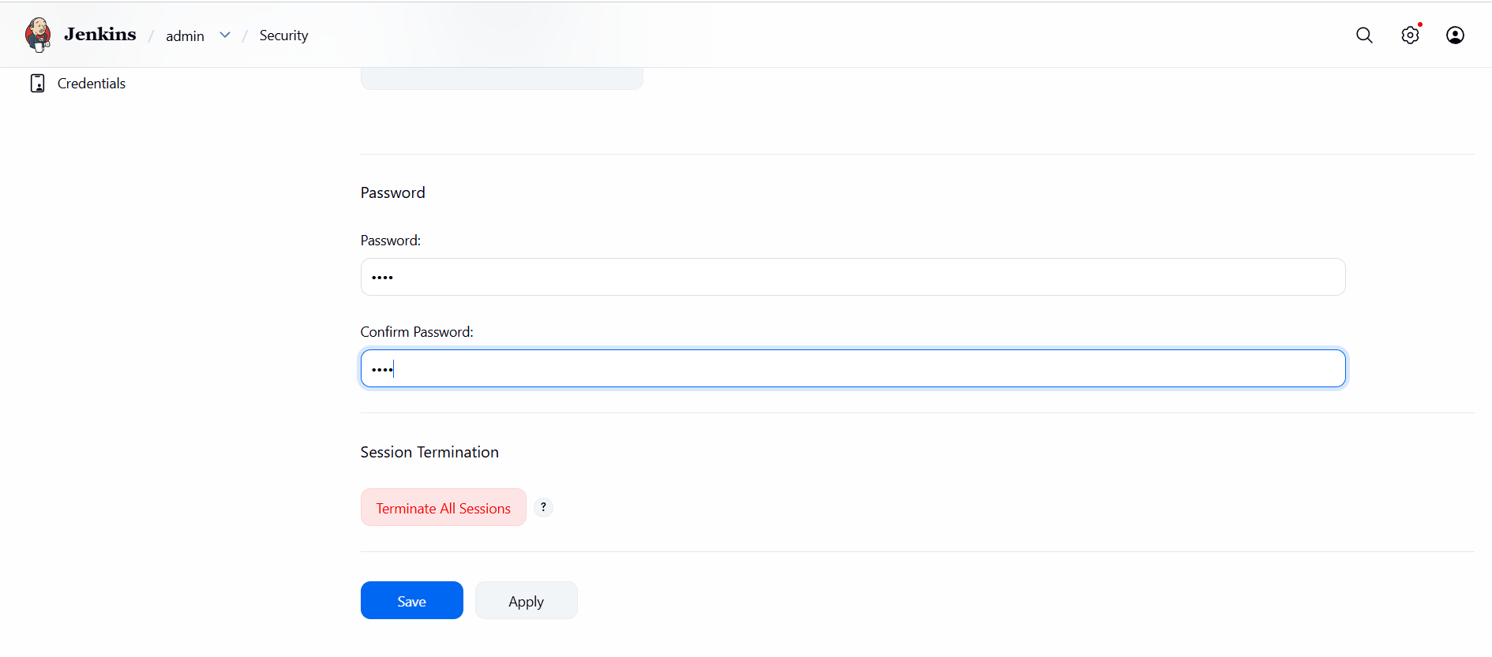
- Create users called DevOps, Testing in Jenkins with Limited access.
Create user
Navigate to the Manage Jenkins page from the Jenkins dashboard --Select Users under the Security section.
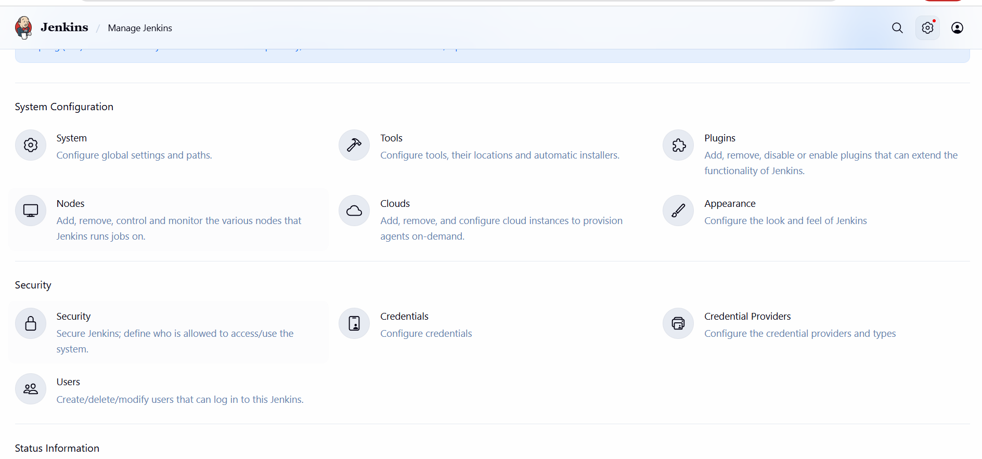

To create a users
On the Users page, select Create User.
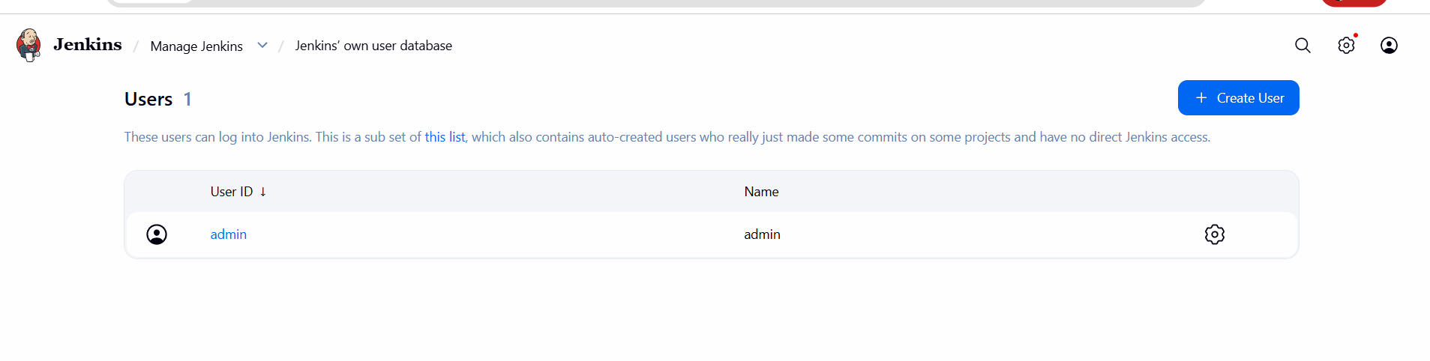

Fill in the required details:
• Username: A unique identifier for the user.
• Password: A secure password for the user.
• Confirm Password: Re-enter the password.
• Full Name: The full name of the user.
• Email Address: The email address of the user.
Created a user named Devops
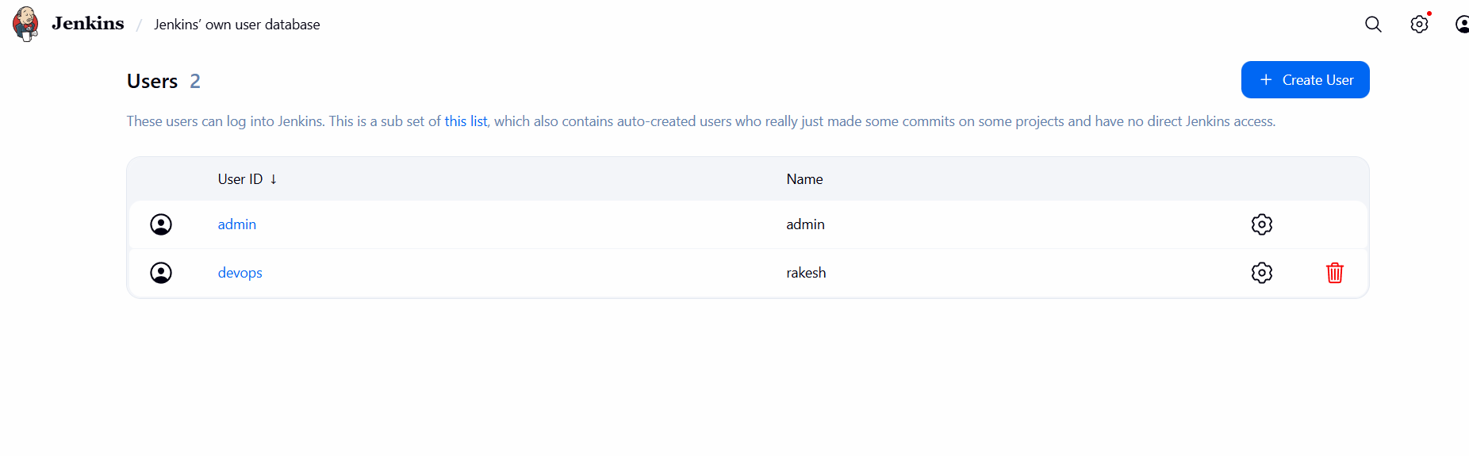
Created a user named testing
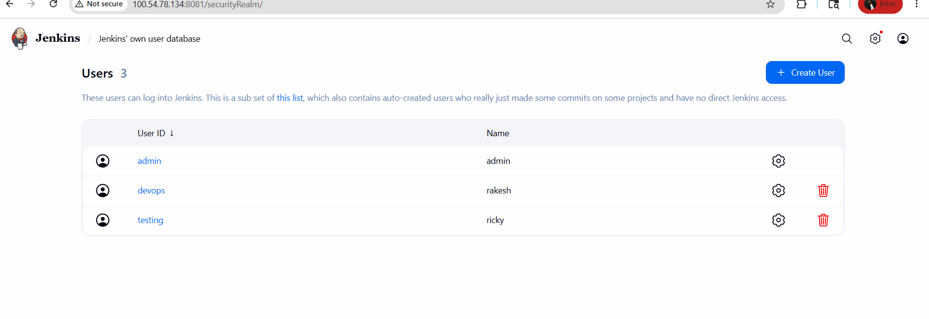

Go to manage Jenkins -- click on plugins
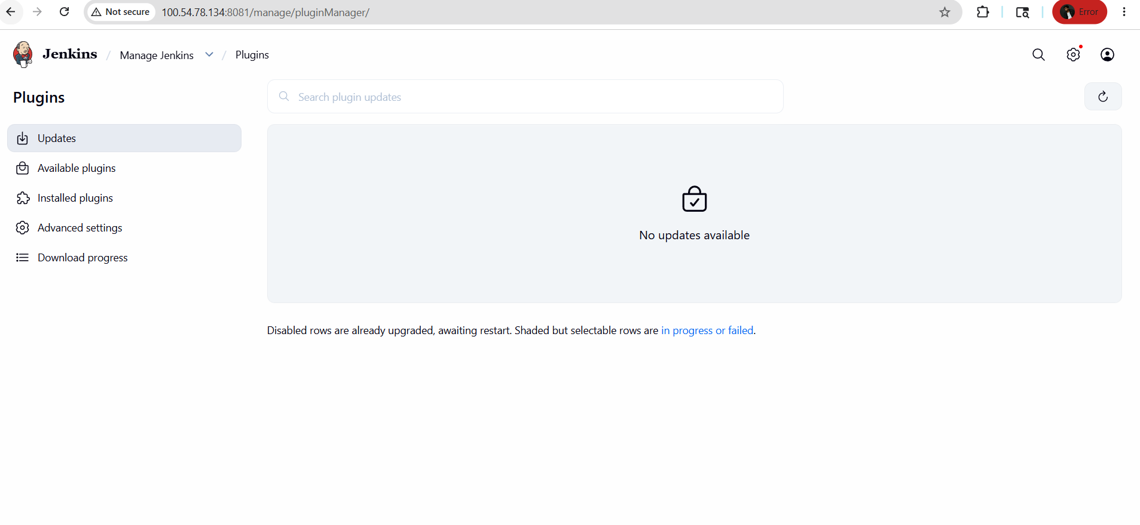
Click on available plugins
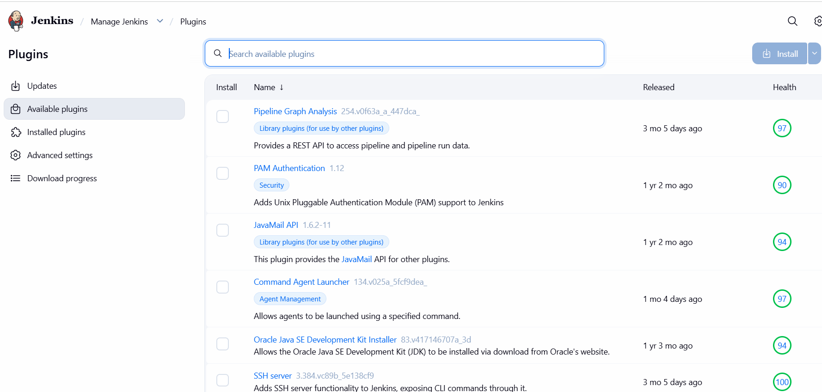
Search Role-based authorization strategy and install
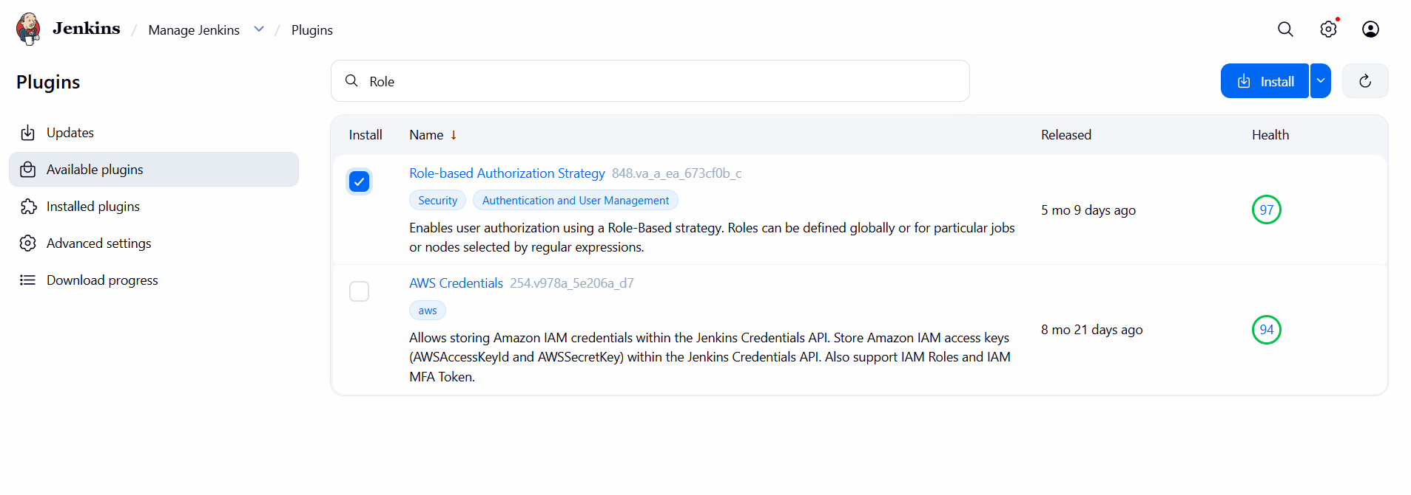
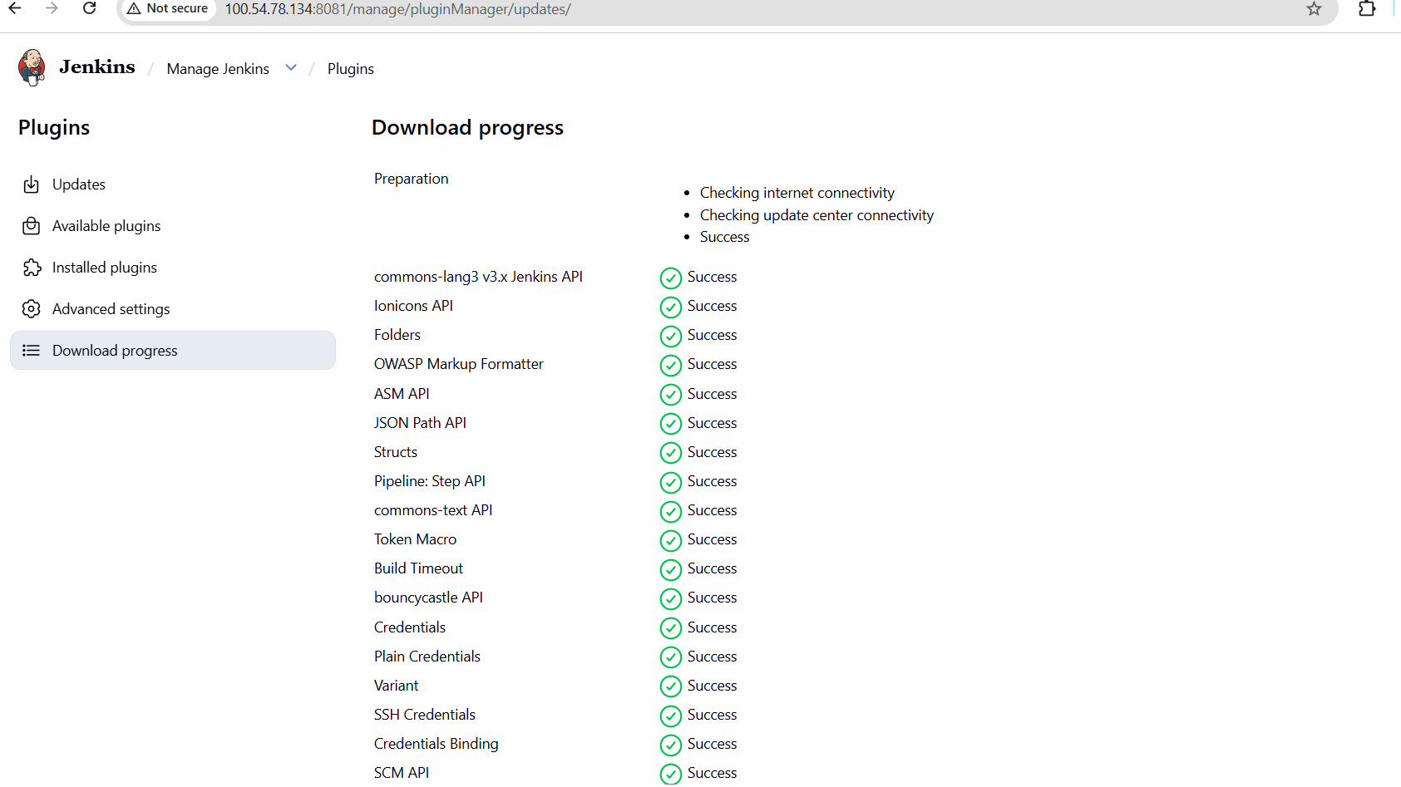
Enable project based on Jenkins
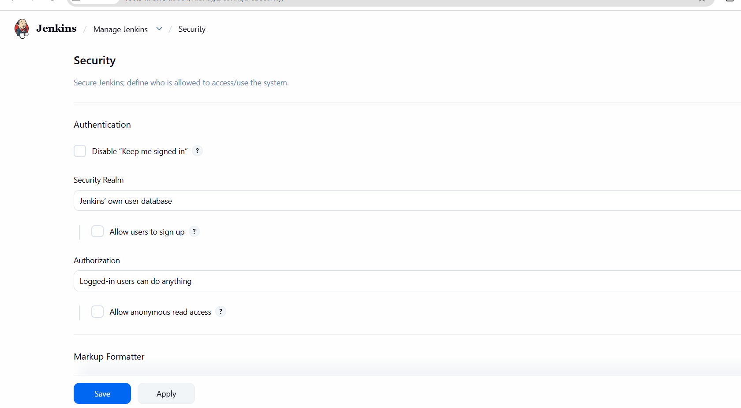
Under authorization select project based metrix authorization strategy and add created users
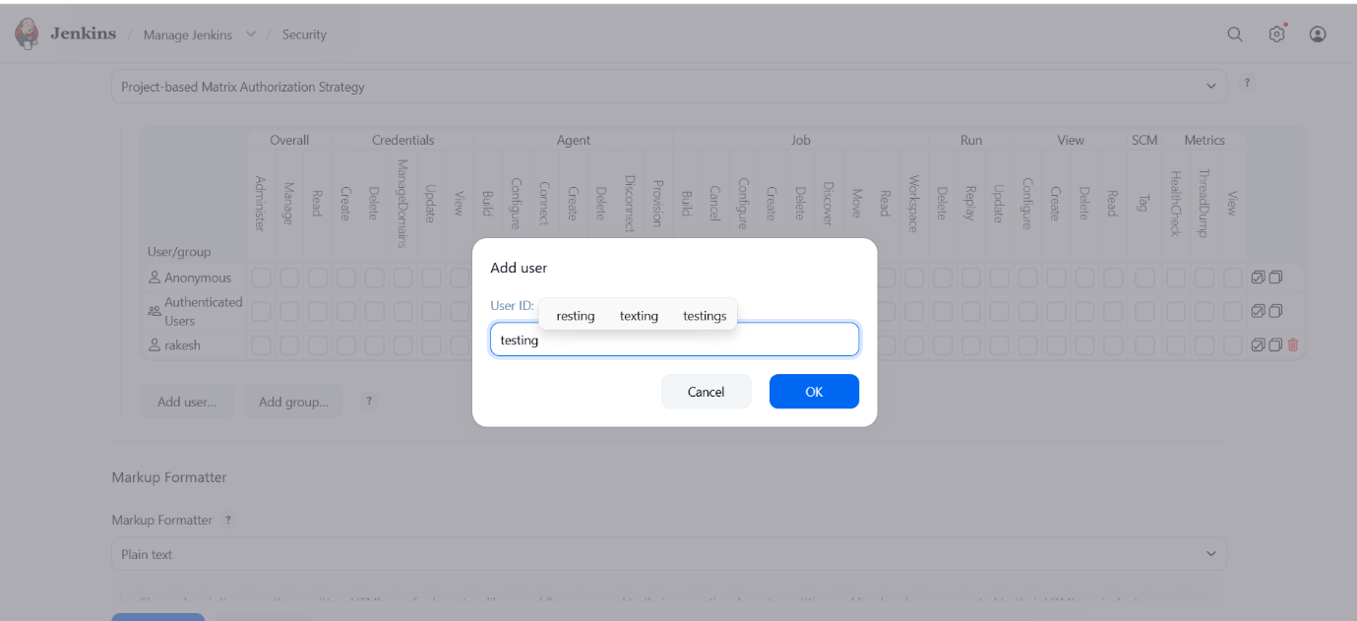
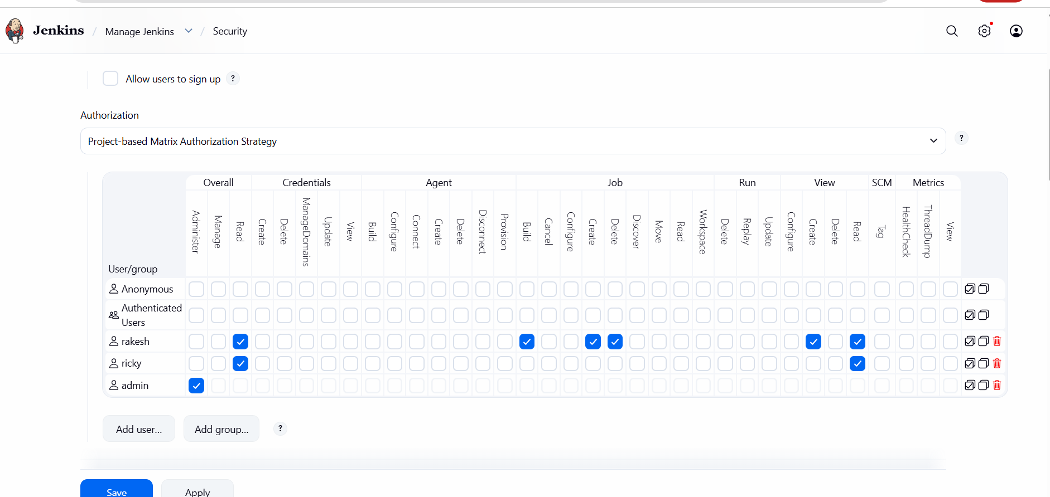
Tried verifying the user
Below for user – testing, I am unable to create as I only have read access

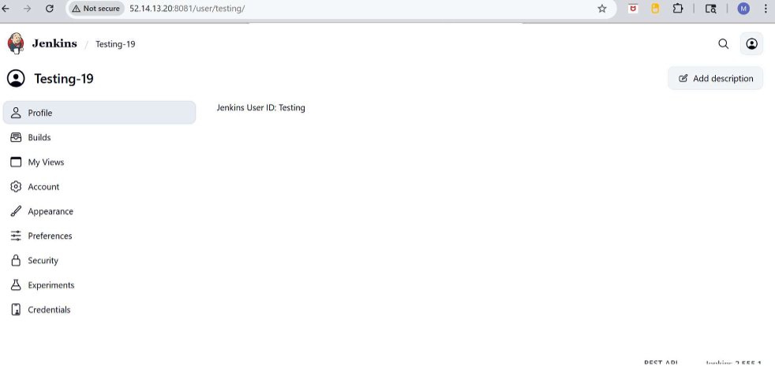

In DevOps user I am able to create a job as I gave create access
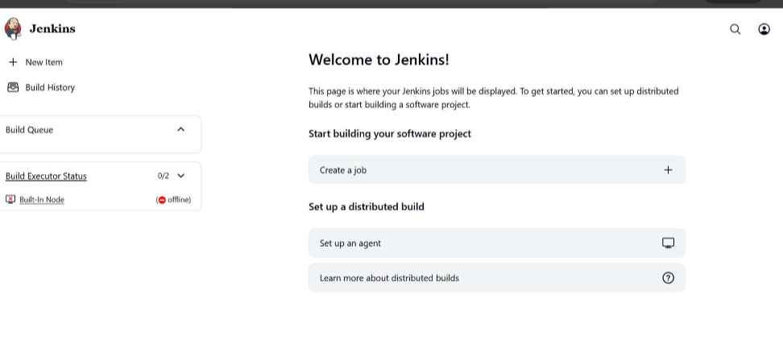

- Configure labels and restrict the jobs to execute based on label only.
Go to manage Jenkins --- click on node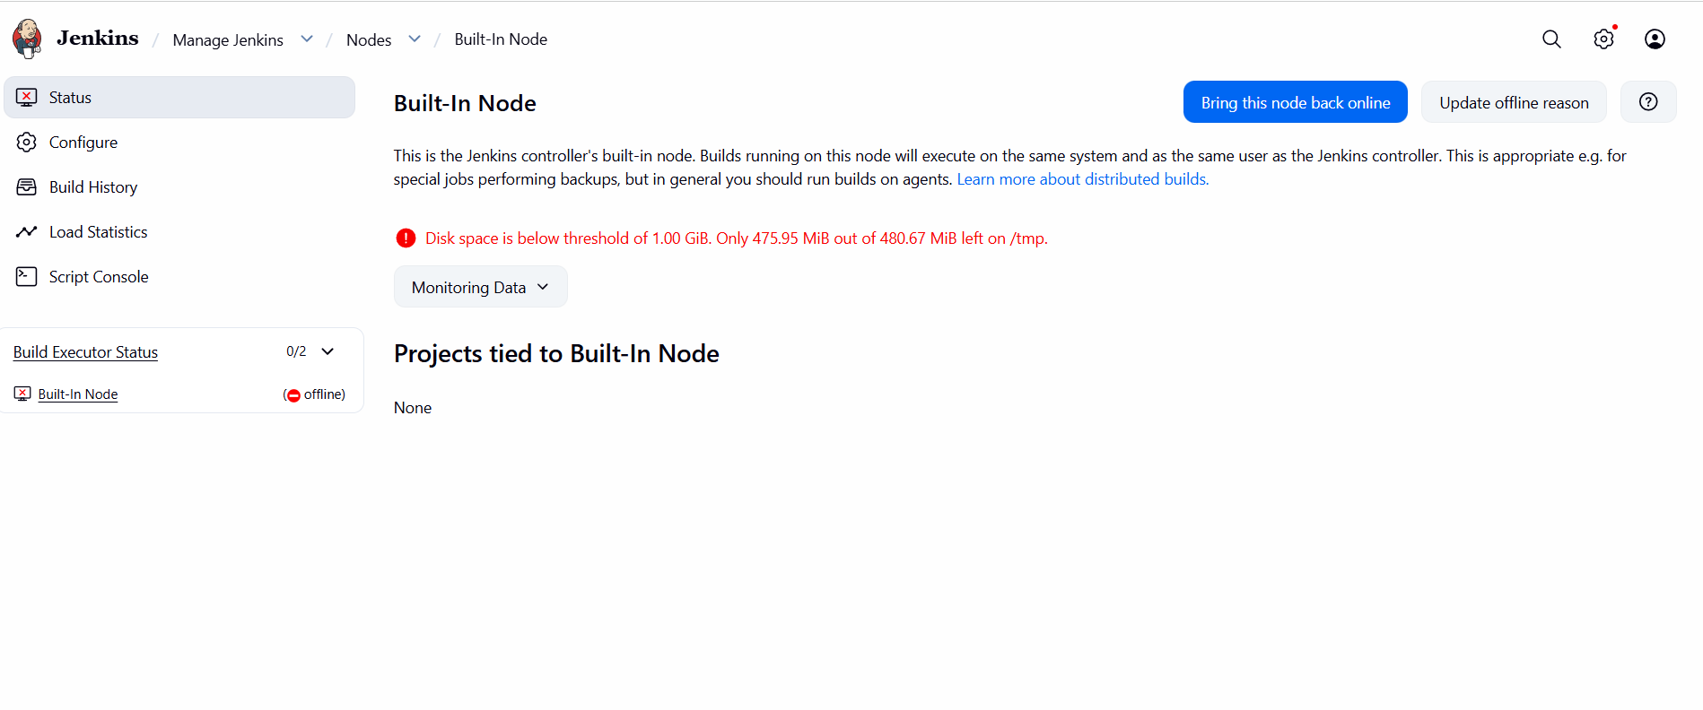Click on built in node
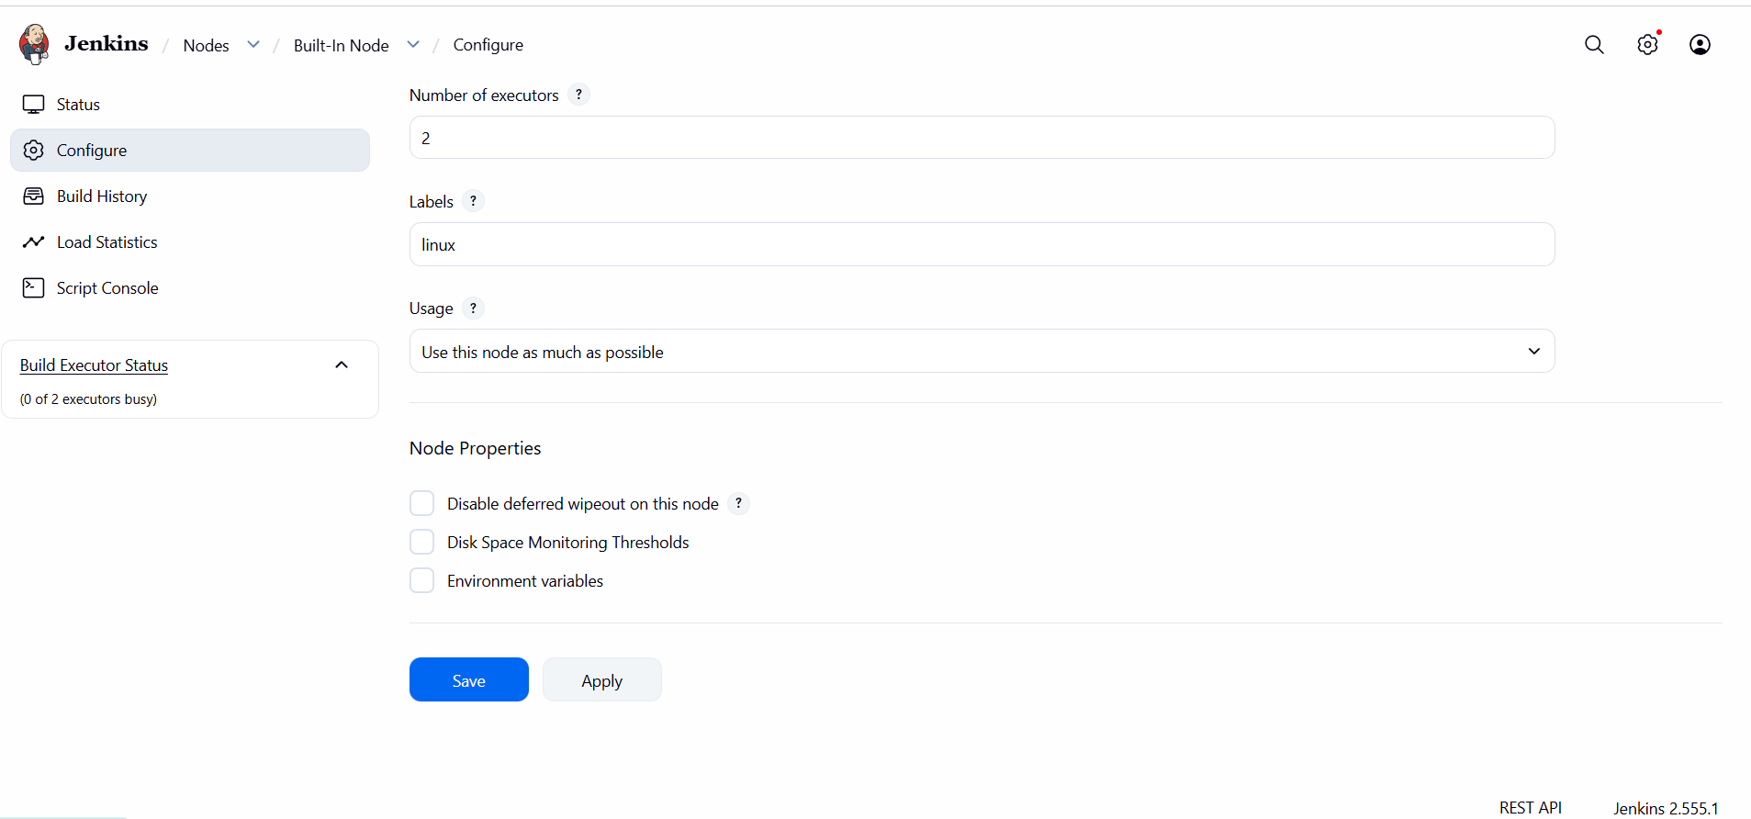
Now created New Item or create a job in Jenkins
Click on new item --- give item name ---choose item type
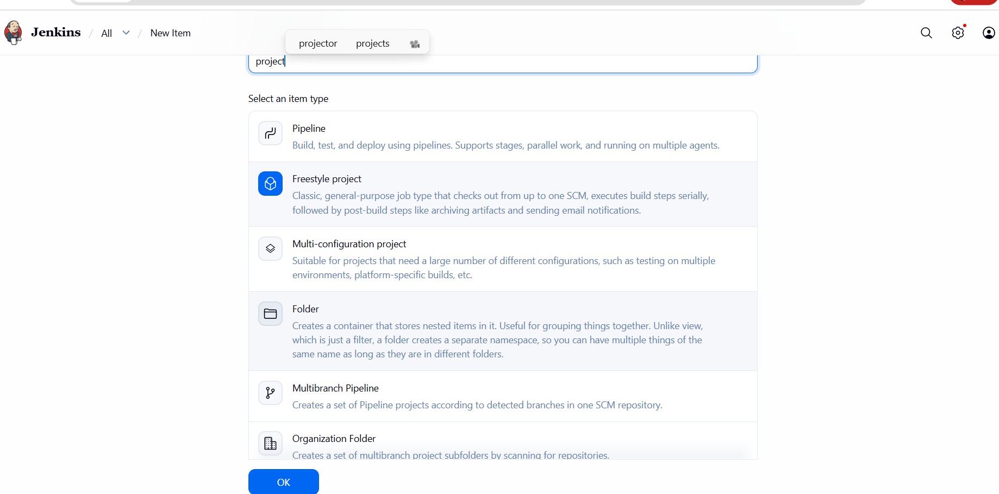
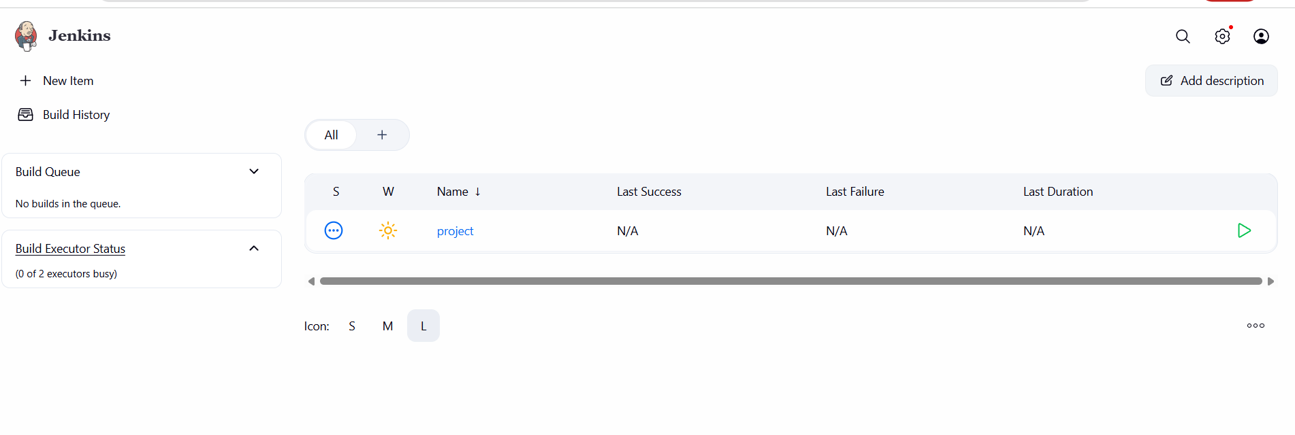
Default we can see Restrict this project run we can add label name
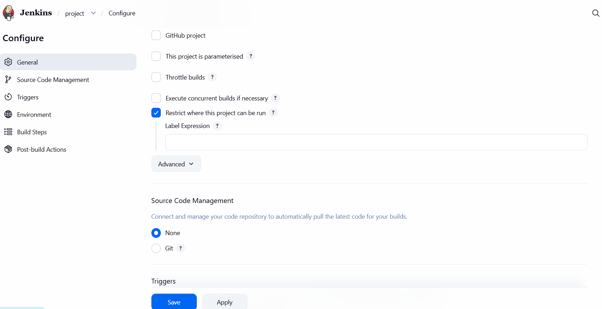
In Build steps select Execute Shell and given command
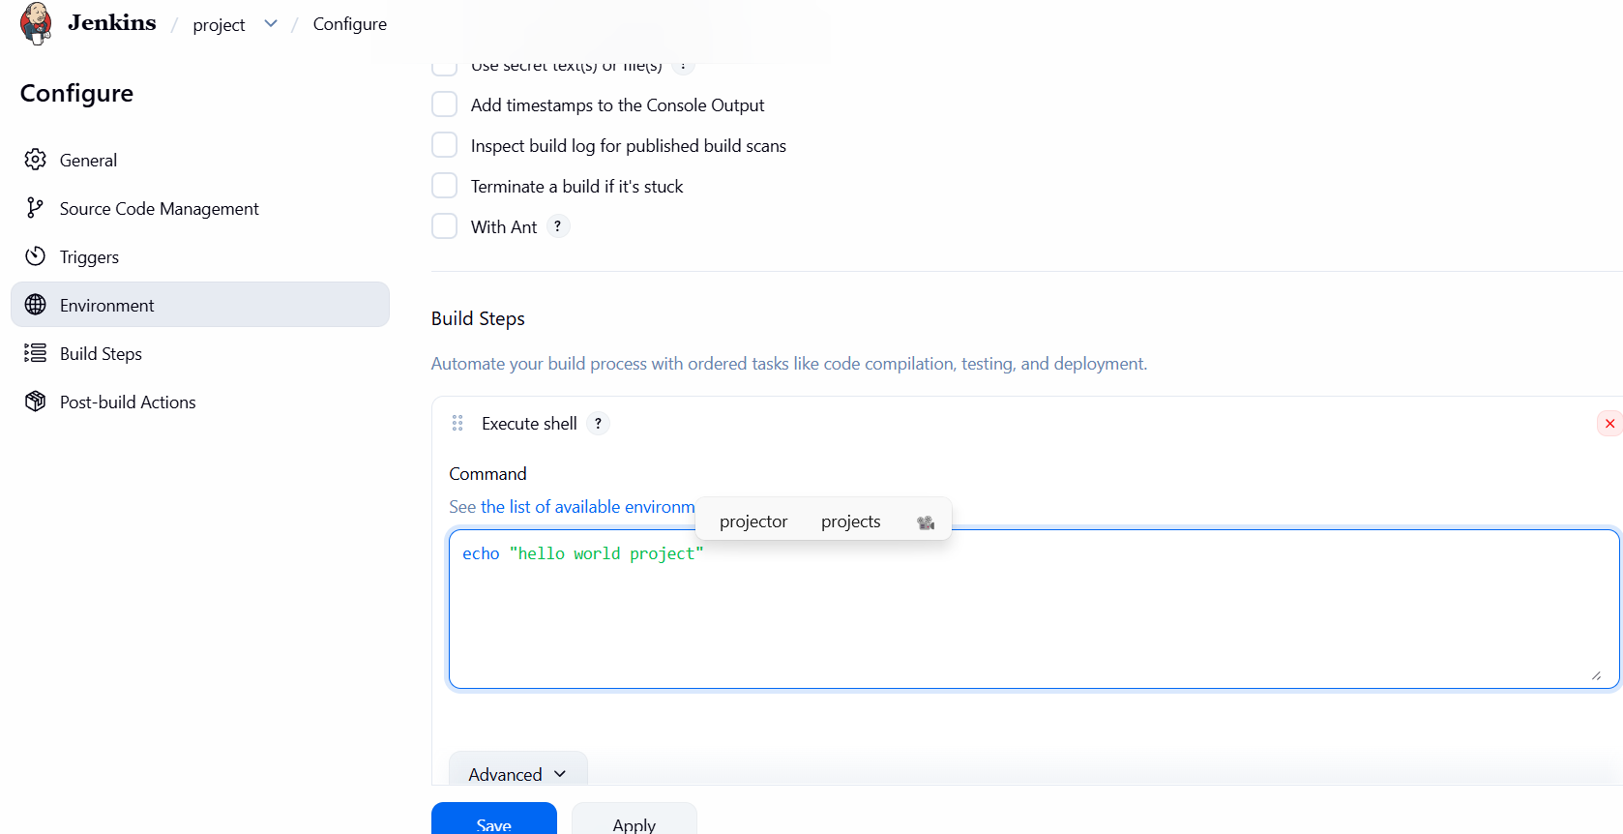
Save and run the build and check the status
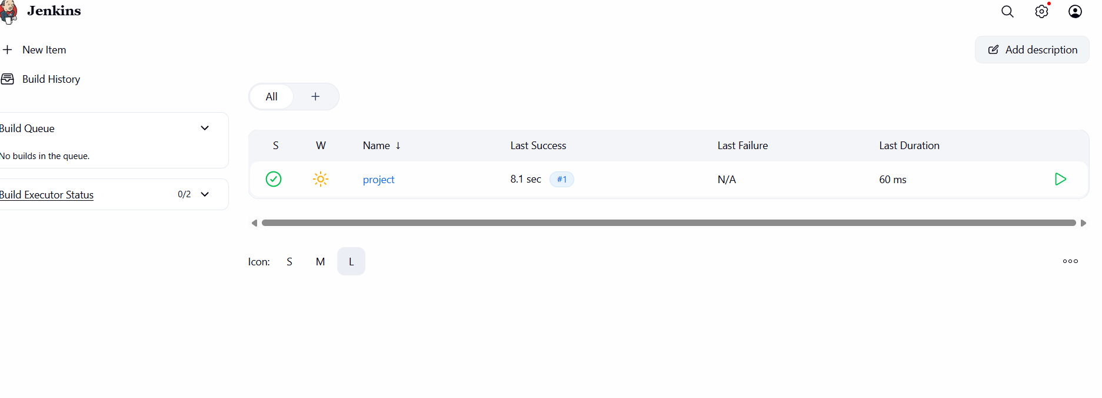
Checked the console running successful
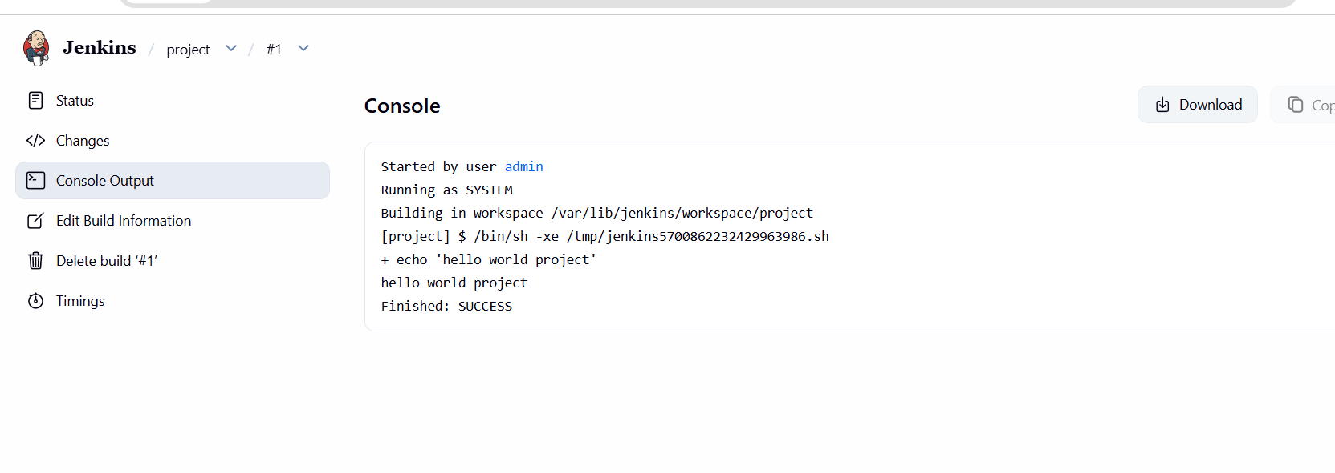

- Create Three sample jobs using the below URL.
  - Source Code:https://github.com/betawins/Techie_horizon_Login_app.git
---- Create a new item as Github-01 in Jenkins
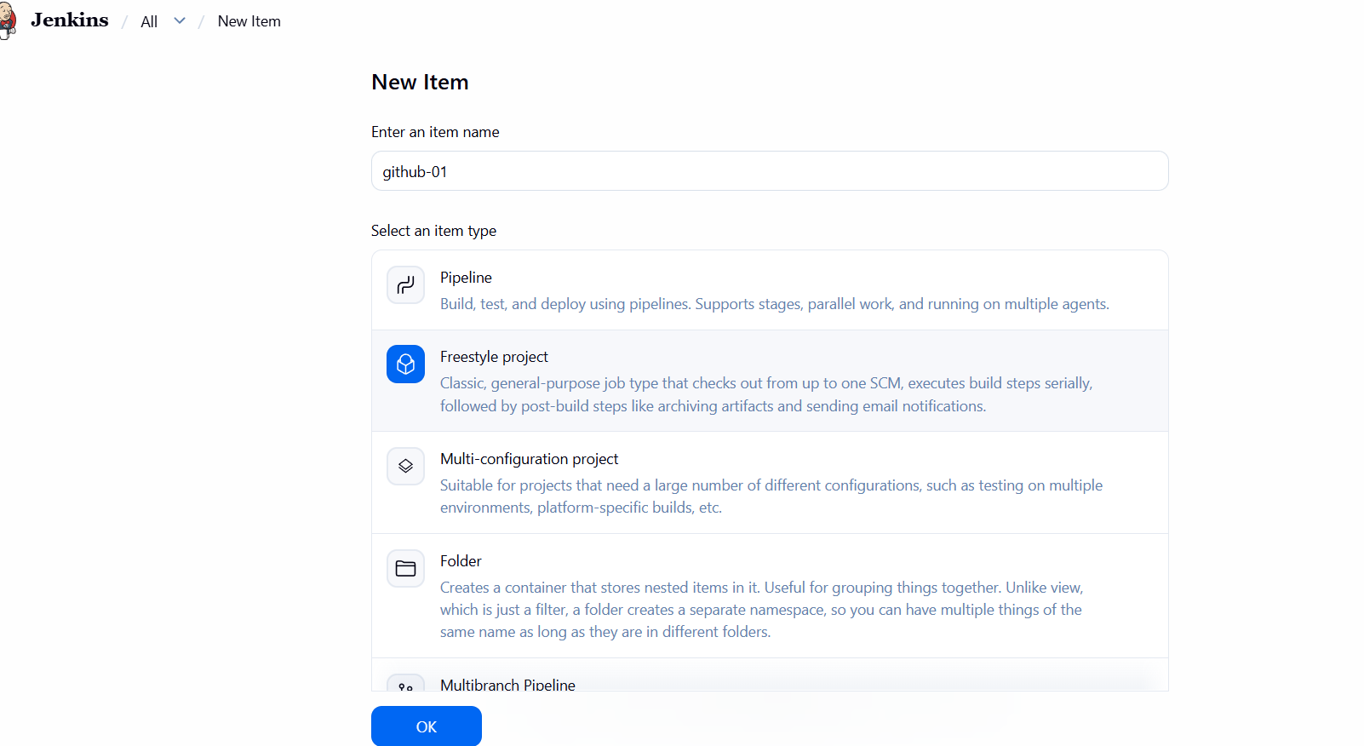
Install Git in gitbash
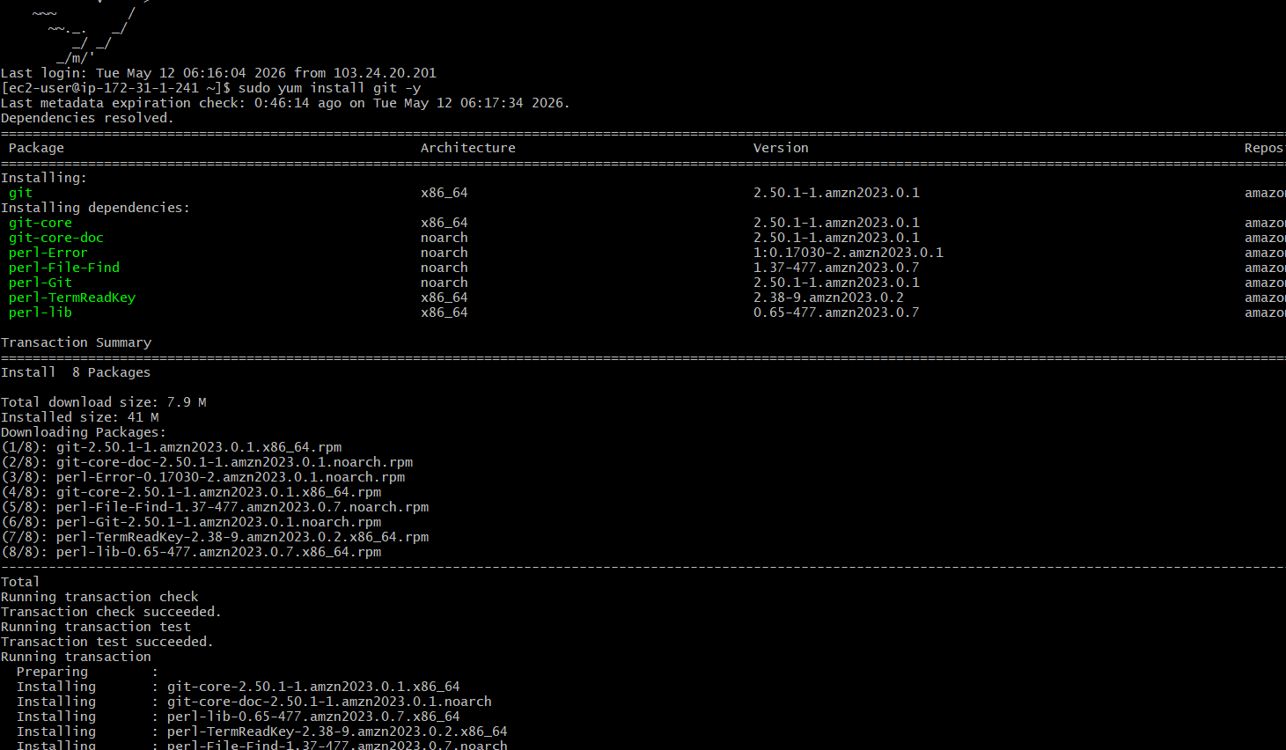
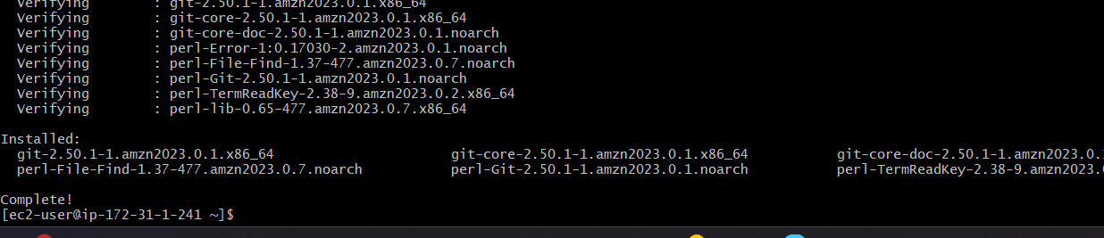
Select Source code management and in that select git and paste url
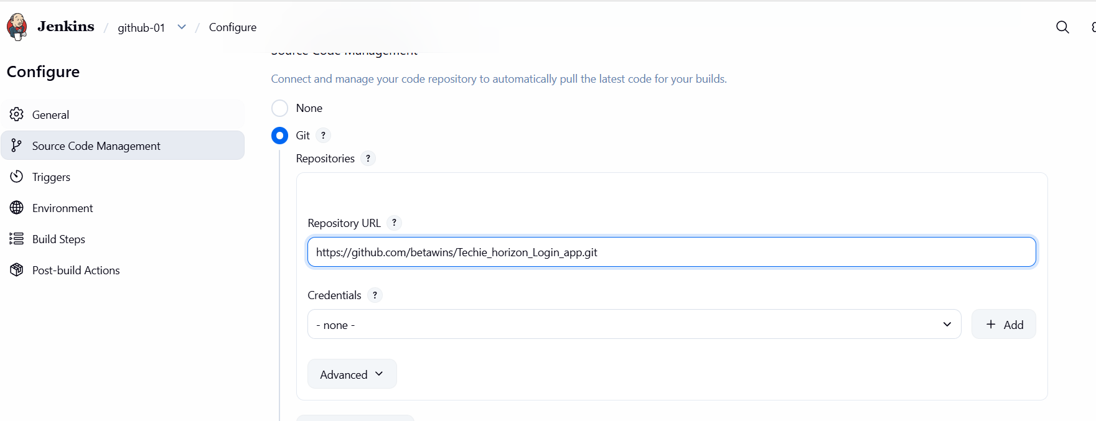
In Build steps select the Execute shell and write command
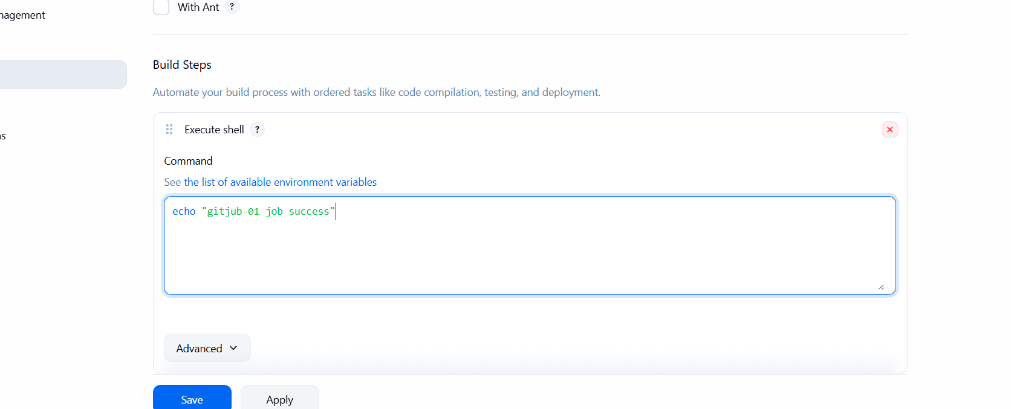
Run the Build Now and output correct
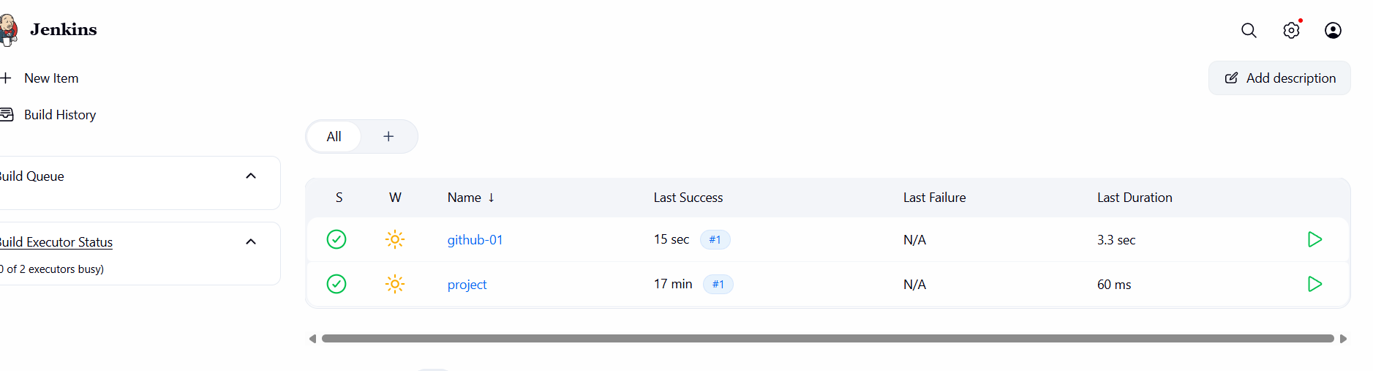
Check the status success 1st one.
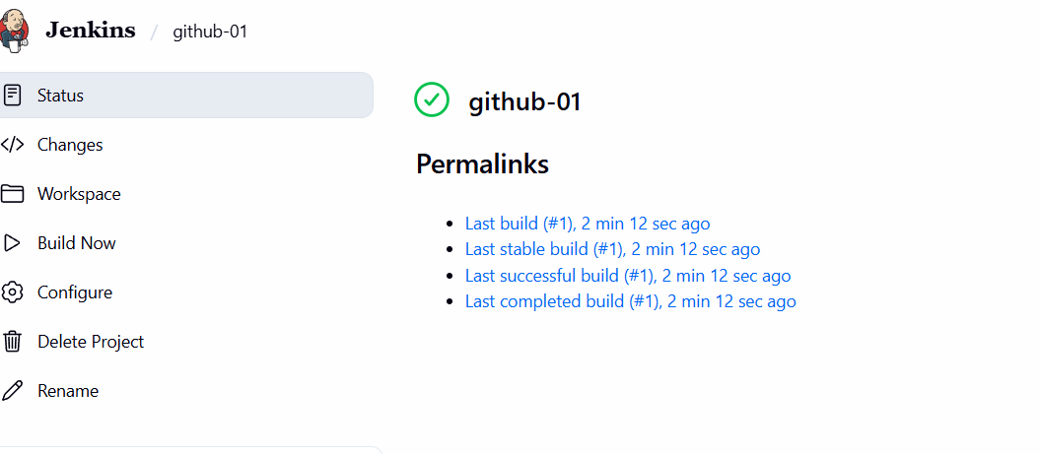
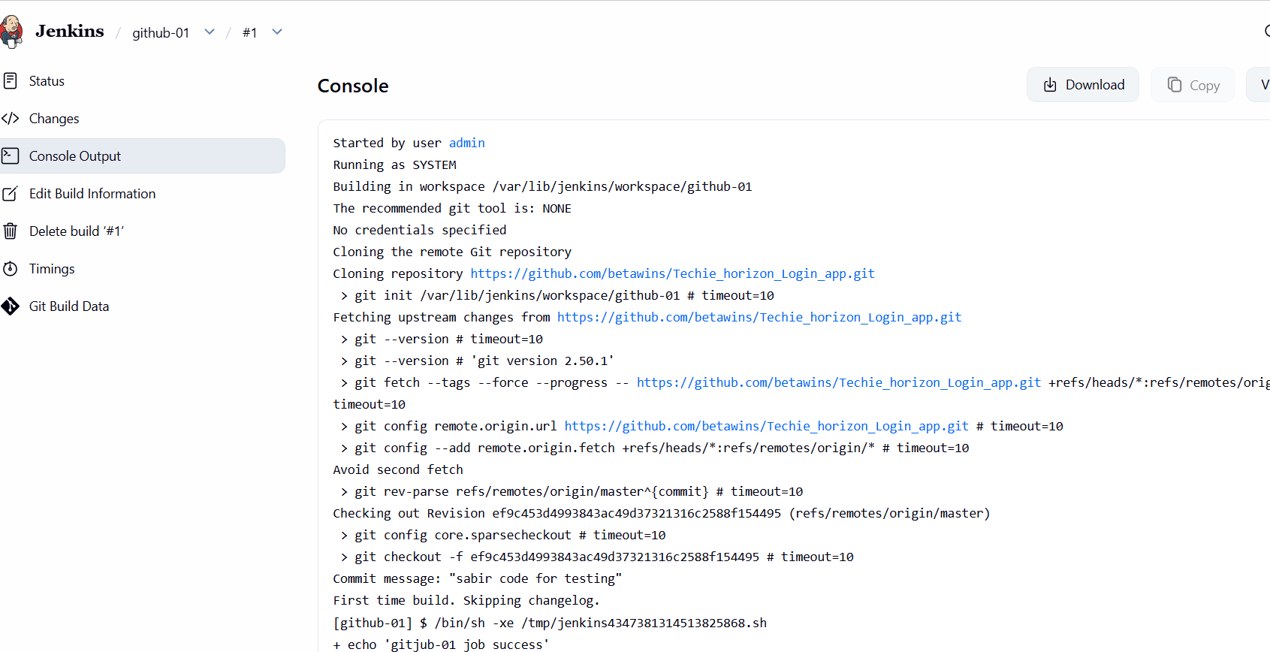
Create 2nd GitHub -02 in new item
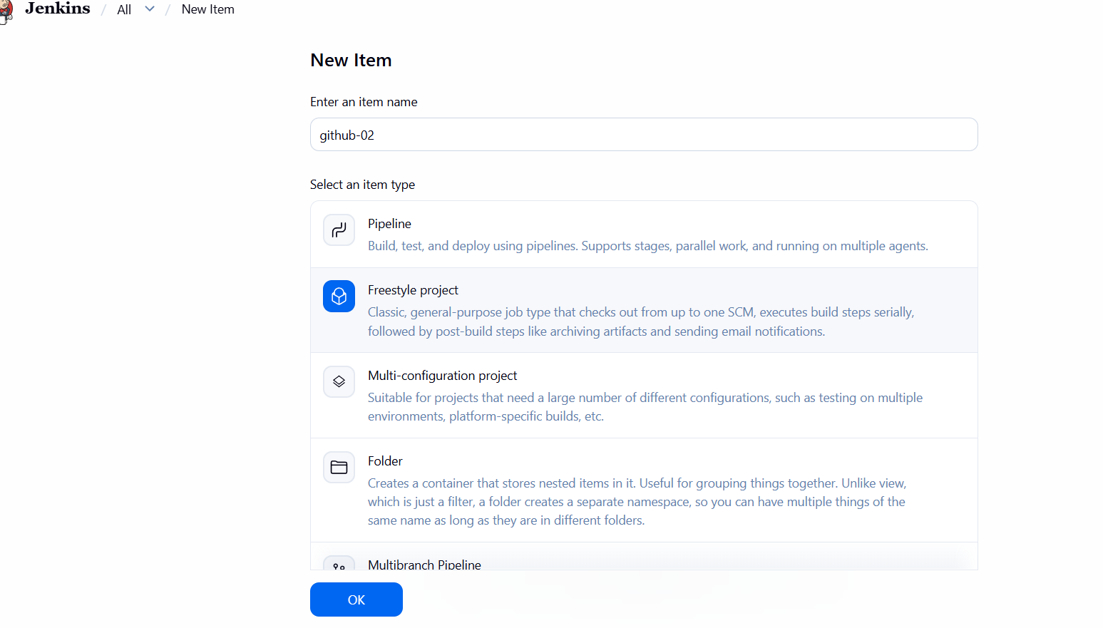
In Source Management change to Git and Paste URL
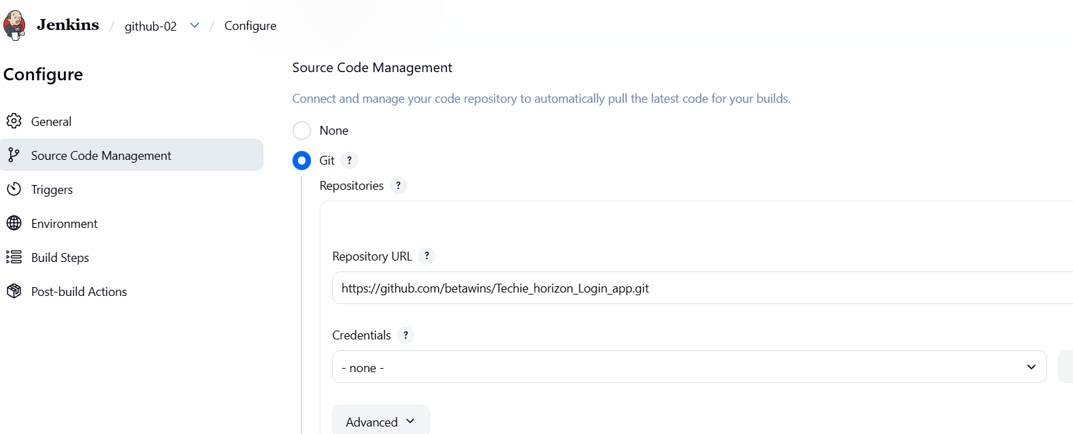
In Build Steps add command and save it
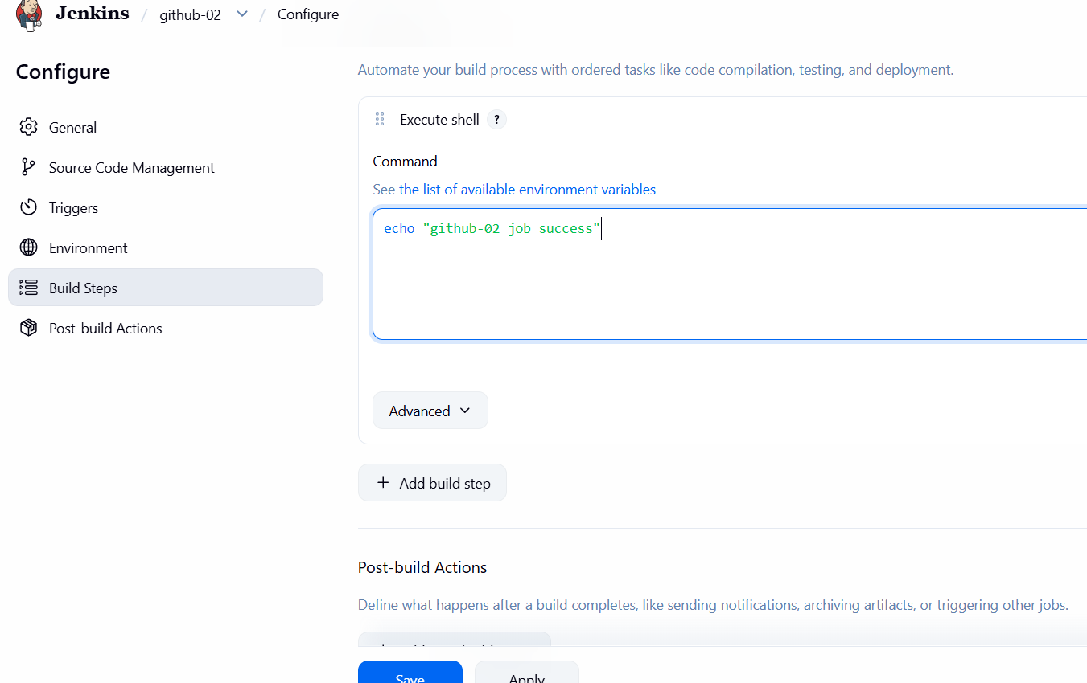
Successful output for 2nd Github-02
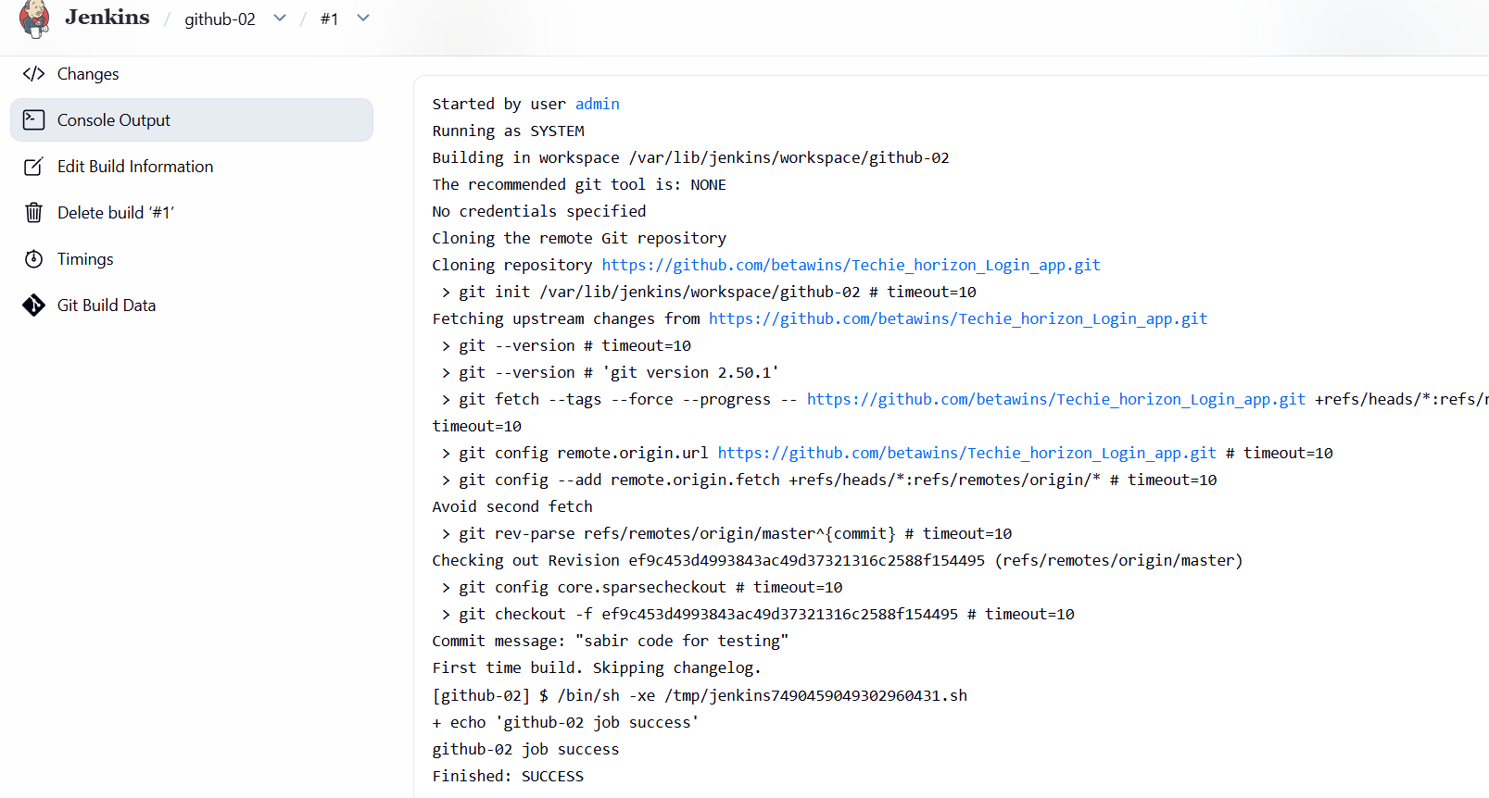
Create New Item in Jenkins as GitHub -03
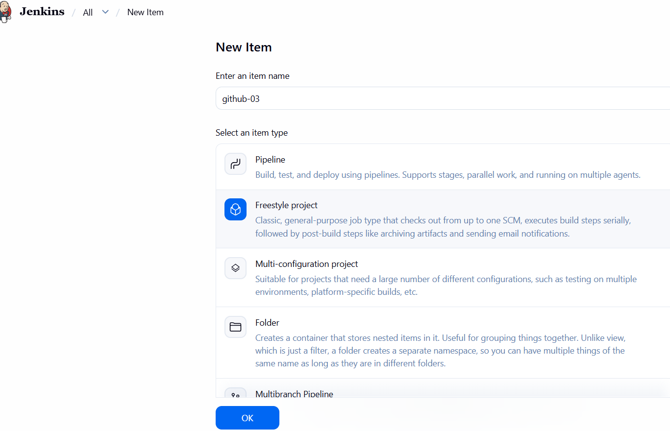
n Source Code change to git and paste Url
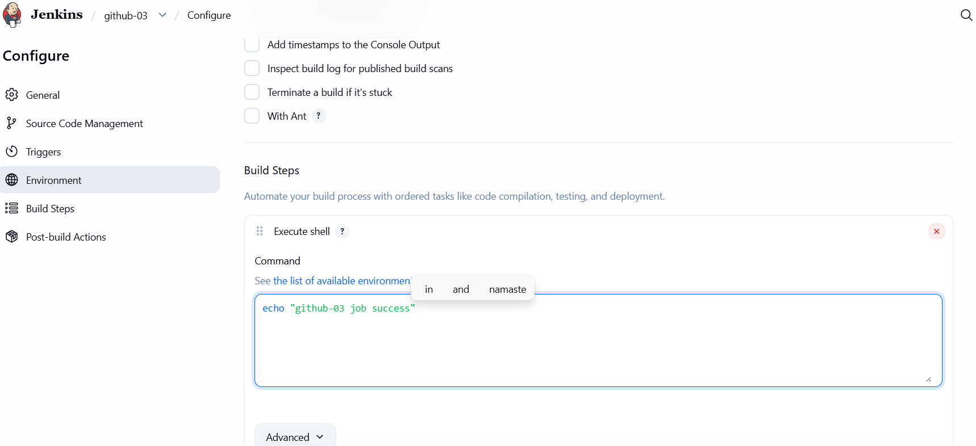In Build steps change to Execute shell and given command and save
Run the Build Now and check the status success
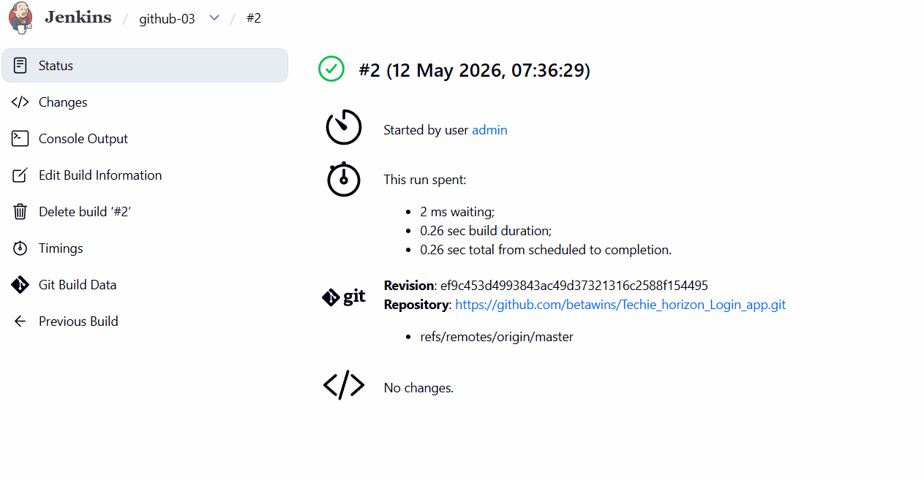

Open console checks their Success
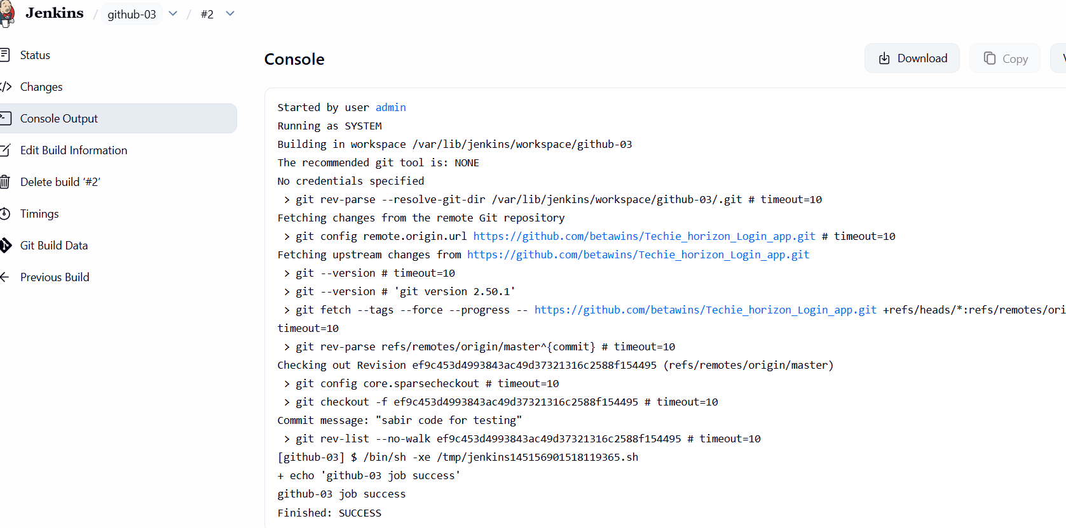

- Create one Jenkins job using GitHub Private repository.
Open GitHub and click on new repository and given name and in the
configuration change private to public
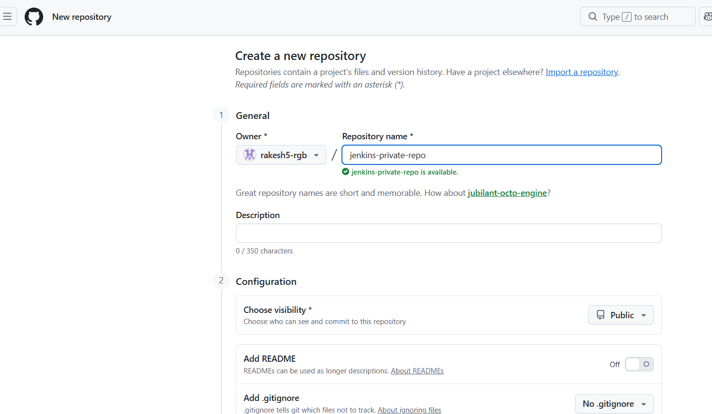
Open settings and generate new token
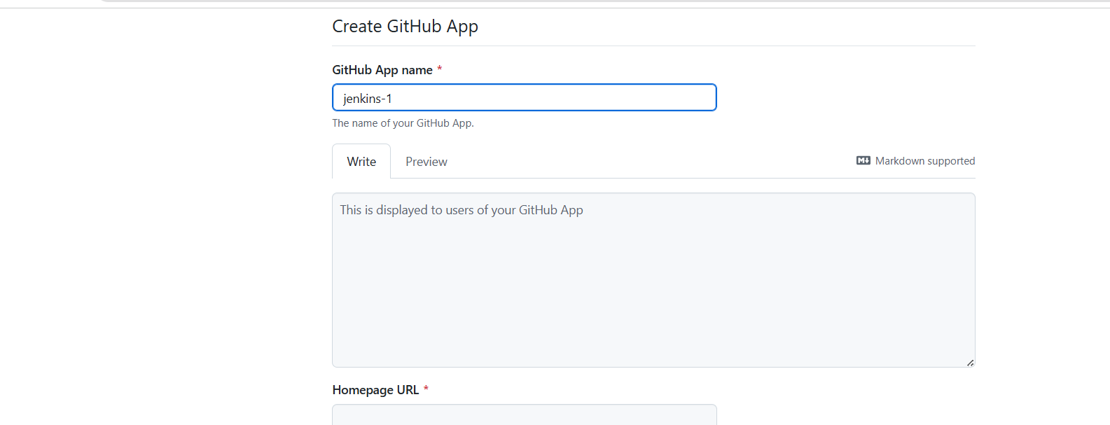
Given name in note and enable repo and generate token and kept safely.
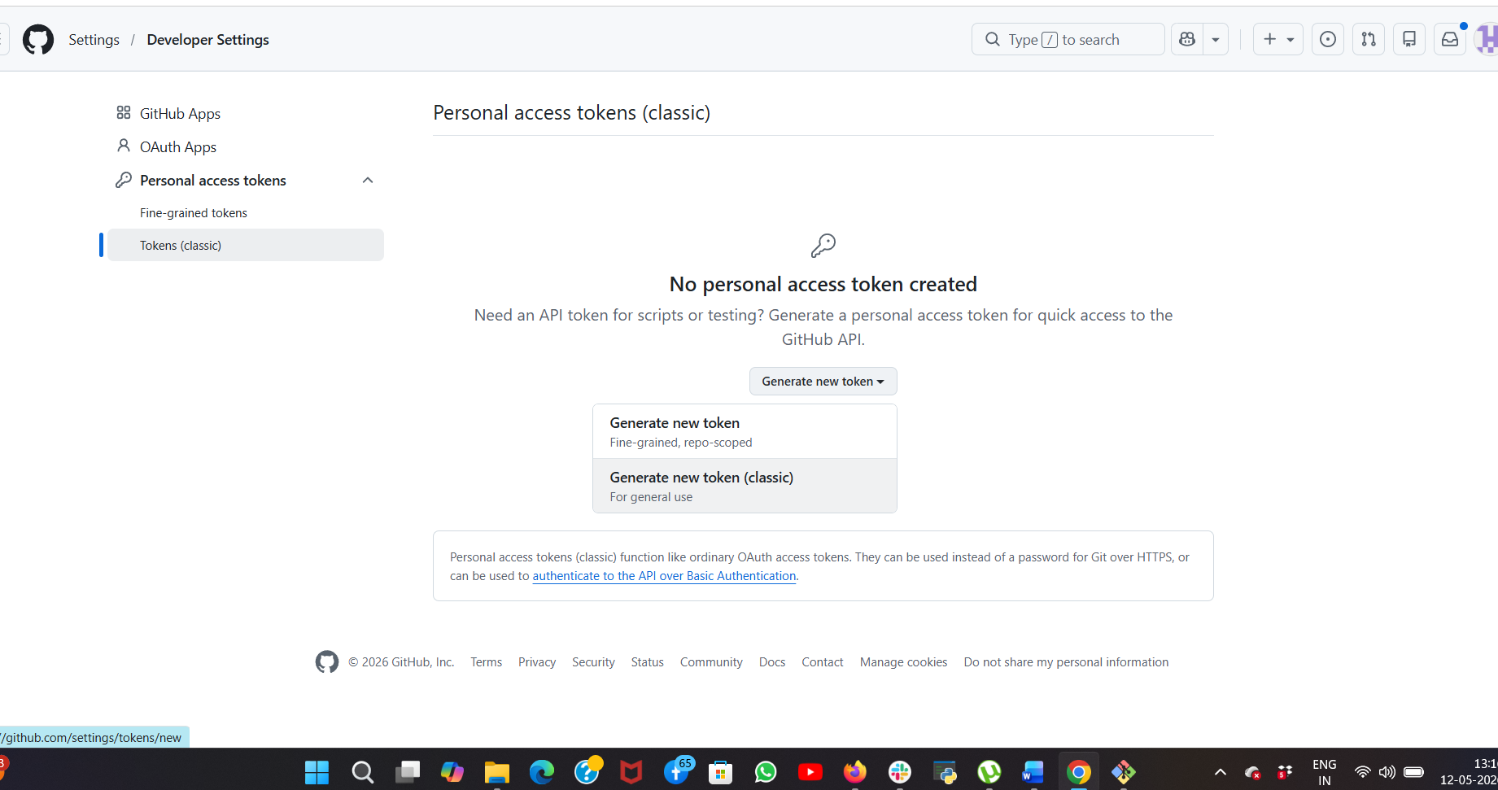
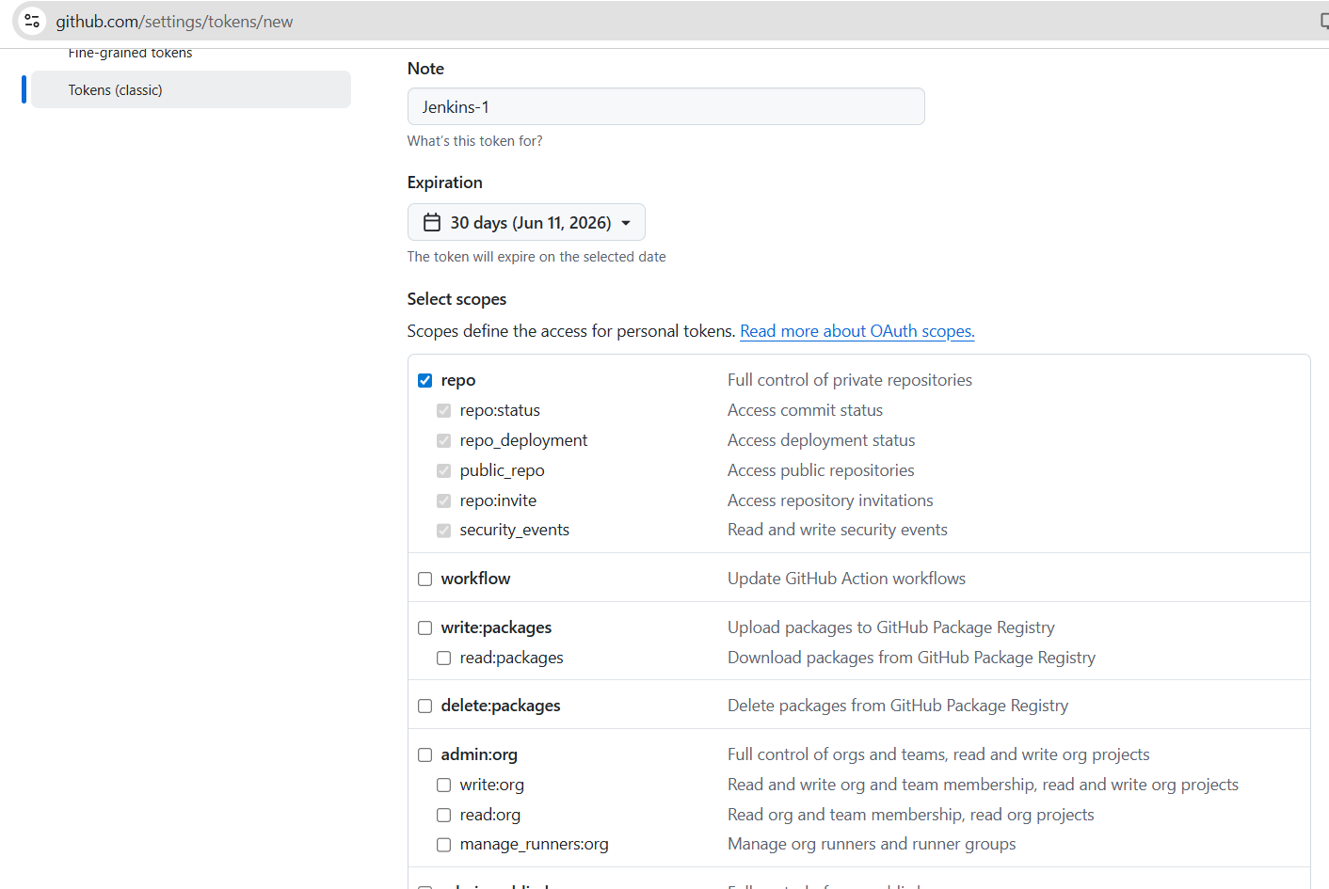

Now open Manage Jenkins in that Credentials
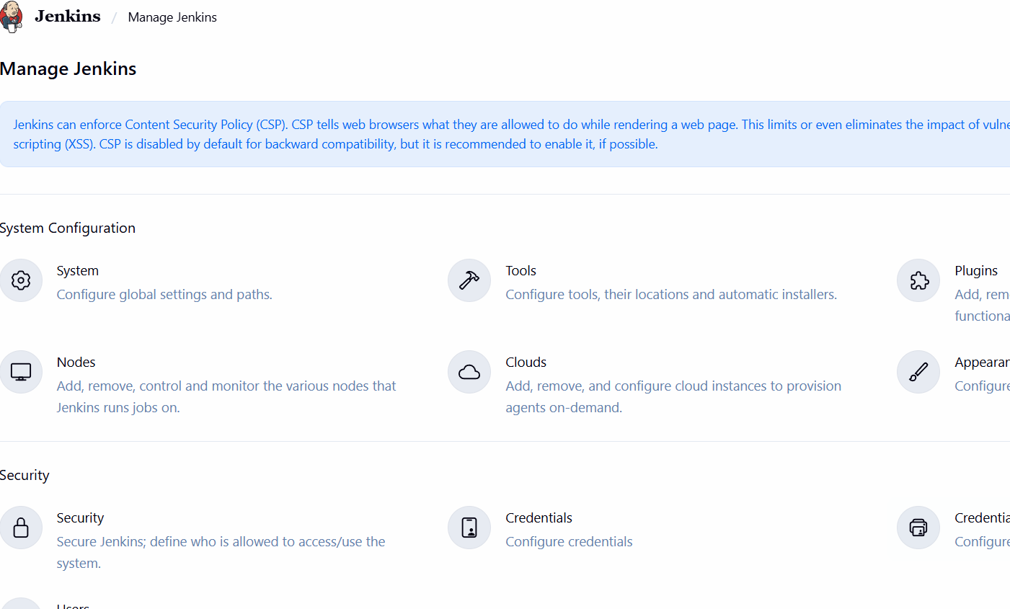
Select Global and Click Add Credentials and select username and password
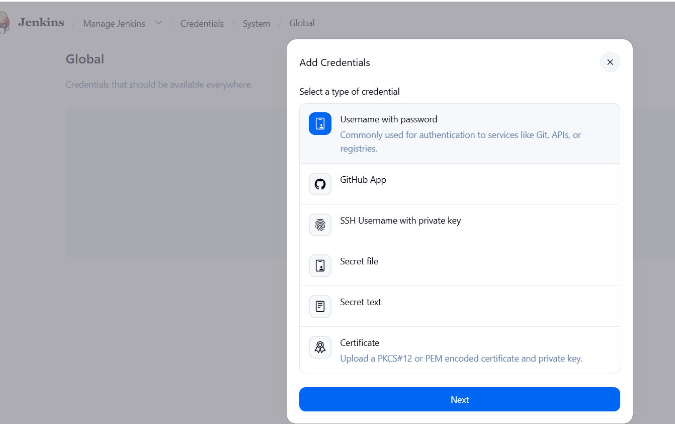

Given details--
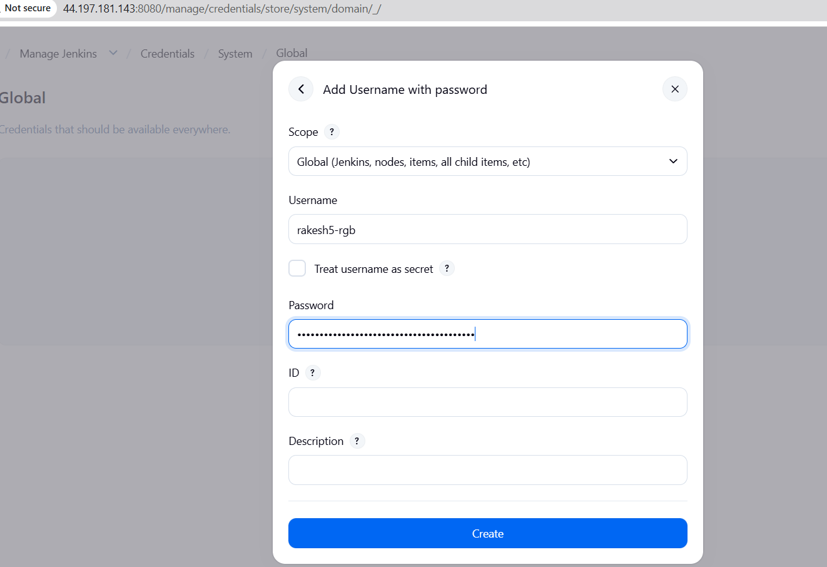
Now created new item as GitHub Private
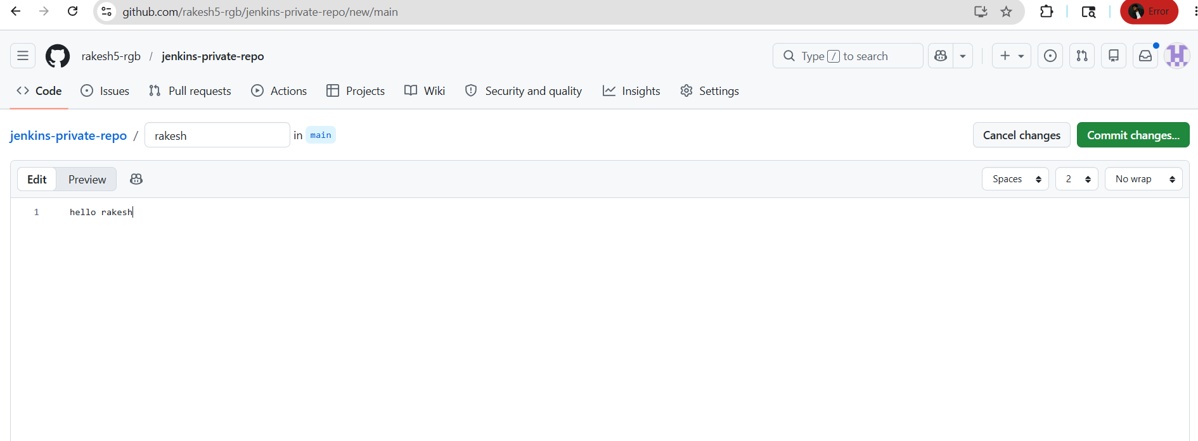

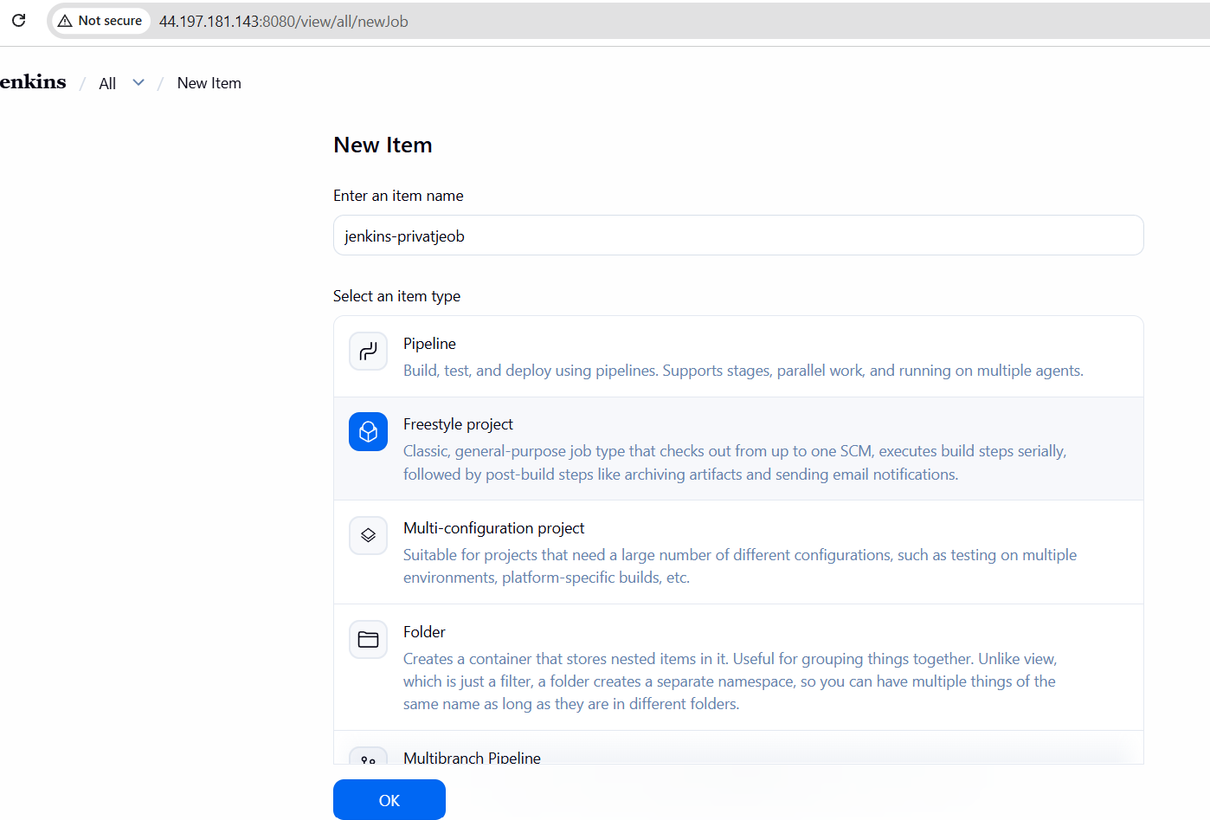
In Source Management change git and added my private git URL
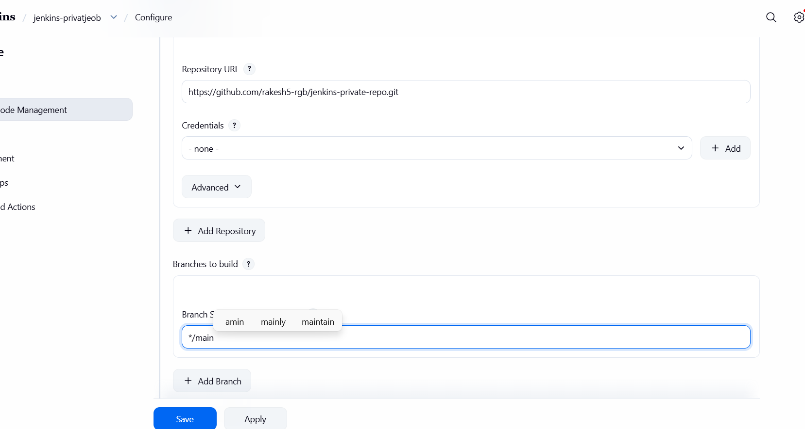
Now Build Steps and Execute Shell and command it and save
Build Now and check the console
